‘Hoodies’ or ‘Altar Boys’
Newspaper stereotyping of teenage boys

Dissertation by Fiona Bawdon
Crime & Criminal Justice MA 2008-2010
Kings College London
Contents
Introduction……………………………………………..page 6
The rise of the hoodie…………................................page 7
How the hoodie panic is lived……………………...page 9
About this dissertation……………………………..page 10
Disclaimers………………………………………...page 12
Chapter 1: Literature Review………………………...page 13
T’was ever thus?.......................................................page 13
The more things change?.........................................page 16
In the eye of the beholder?.......................................page 21
Moral panic! What is it good for?............................page 24
The Bulger and Lawrence murders……………….page 27
Suitable victims; suitable enemies………………...page 29
Footnotes………………………………………….page 33
Chapter 2: Boys’ Attitudes to Media Coverage...........page 35
Research methodology and background………….page 36
Sample…………………………………………….page 38
Findings……………………………………………page 40
Footnotes……………………………………………page 44
Chapter 3: Newspaper Content Analysis…………….page 46
Analysis of content over 12-month period…………..page 46
Methodology and aims……………………………….page 46
Findings……………………………………………….page 48
Content analysis – based on purposive sample……….page 51
Methodology…………………………………………..page 51
Christie’s concept of the ‘ideal victim’………………page 54
Footnotes…………………………………………… page 64
Conclusions……………………………………………..page 66
Overview……………………………………………….page 66
Future research…………………………………………page 68
Bibliography………………………………………….page 72
Appendices…………………………………………….page 78
Appendix 1: Photograph of goggle hoodie
Appendix 2: Online survey results
Appendix 3: Presentation of online survey results and content analysis
Appendix 4: Women in Journalism report (10 March 2009)
Appendix 5: Women in Journalism press release (10 March 2009)
Appendix 6: Independent article, 13 March 2009
Appendix 7: Presentation of quotes research findings

14,422 words
Cover photo: Caroline O’Dwyer
Introduction
On 23 February 2009, ‘Denis’, a salt-of-the-earth style columnist on the Huddersfield Daily Examiner, wrote about an encounter with hooded youths, which had left him shocked.
Denis had gone to collect a takeaway one evening only to find the shop doorway blocked ‘by a group of youngsters…wearing hoods and blank expressions.’ He was agonising over whether the safest course would be to ‘give them a hard stare’ or ‘avoid eye contact altogether’, when something shocking happened: they ‘politely got out of my way so I could collect my waiting meal’. ‘One of those sitting moved his legs, opened the door for me and told his mate to move….and [they] opened the door for me again as I left.’
How did we get to the point where a young man displaying every day common courtesy, like the one Denis encountered, becomes newsworthy?
This dissertation will attempt to explore this issue by looking at how the current moral panic around teenage boys as yobs and hoodies is manifested in the media, and how (to use Golding and Middleton’s phrase) it is being ‘lived and [having] substantive effects’ (as quoted by David and Bourhill 1997, page 30).
My starting point is that the hoodie phenomenon has resulted in the media’s reflex demonisation of all teenage boys – rather than just those who are identified as members of deviant groups. It is now not so much a question of problem youths, but that all youths are a problem.
Brown suggests the 1990s saw the replacement of ‘discrete’ panics surrounding relatively small groups of young people (punks, mods, muggers) with a ‘total panic’ surrounding children and young people generally (Brown 2005, page 70). Brown says the media is now not just concerned with the spectacular and deviant, but with the ‘demonisation and spectacularisation of the mundane, the everyday.’ (page 70).
The rise of the hoodie
The most potent symbol of feral and threatening youth in recent years is the omnipresent hooded sweat top, or hoodie, the wearing of which alone can now be construed in the media as anti-social. For the media, the description ‘hoodie’ has become shorthand for dangerous, mainly (but not exclusively) urban, youth; hoodies are associated with anti-social behaviour in its most generalised, nebulous form, and specifically with what has come to be known as ‘knife crime’. For much of the media, hoodies and knives are inextricably linked.
One newspaper, the Sunday Express, mounted a campaign to ‘ban the hood for good’, on the basis that ‘high streets and public transport would be safer if hoods were outlawed and exclusion zones imposed’ (quoted by Treadwell 2008, page 130). The lack of distinction between what the garment supposedly signifies and the garment itself, means that every teen in the country (along with most of the rest of us) is now a potential ‘hoodie’. This has inevitably led to the odd gleeful media interview with a bemused pensioner, recounting that she was ordered to take down the hood of her mauve BHS cardi by an over officious doorman as there can be no exceptions to the ‘no hoodies’ rule.
Who are these dangerous hoodies? For the press, all teens are now potential hoodies (because all it takes is to wear a hooded top), so every teen must be treated as suspect. In newspaper reporting of teenagers, there is now a reverse burden of proof: teens are no longer presumed ‘innocent’ – that is, virtuous, harmless, ordinary; they are presumed hoodies, unless they can demonstrate they are not.
In late 2008, Daily Mail columnist Richard Littlejohn wrote: ‘No one crosses the road if they spot a crocodile of Boy Scouts coming in the other direction. But nor does anyone in their right mind risk walking through a scrum of hoodies hogging the pavement – not unless they fancy a knife in their ribs.’ (Daily Mail, 18 November 2008) Thus for the columnists like Littlejohn and much of the media, unless young people are not boy scouts, they must be knife-wielding hoodies.
How the ‘hoodie panic’ is lived
As I demonstrate in chapter 2, teen boys themselves are strongly influenced by newspaper stories about teenagers as yobs and hoodies. My research found that young men are wary of teenagers they don’t know, with over half citing media stories as a reason for their wariness. Nearly three-quarters said they had changed their behaviour as a result.
Evidence that all young people are now viewed as at least potential hoodies (and, therefore, potentially if not actually dangerous) is not hard to find: a parent can no longer buy a penknife for a teenager going on a camping trip (personal experience); an ad for an online game featuring a hooded figure holding a knife is banned (Guardian, 14 July 2010).
There is also anecdotal evidence that younger and younger children are now being swept up in the hoodie panic, in a way that would not be possible when fears are restricted to identifiable ‘deviant’ groups, rather than young people as a whole. For example, in 2005, a year-two boy (aged 7) at an urban primary school brought a penknife into class. He was well known for bringing in contraband (more usually McDonald’s toys), to get attention. There was no suggestion he meant to harm anyone and the incident was not seen as serious. The head teacher spoke to his mother and, as punishment, he spent a day in the head’s office.
Three years later, a year-four boy (age 10) at the same school, also brought a penknife into school. Again, there was no suggestion he intended to harm anyone (he had done so at the urging of friends who wanted to see it). This time the incident was seen as very serious and the boy was permanently excluded (despite a petition by other parents calling for his reinstatement) (personal experience).
Same inner city borough; same school; same head teacher; same ‘offence’. (Coincidentally, both boys were from Asian families and both came from what could loosely be described as ‘difficult’ backgrounds). The only thing that had changed was that ‘a totalizing discourse of panic’ (Brown 2005, page 64) about young people had erupted in the media in the intervening three years.
About this dissertation
This dissertation will aim to set the current panic around youth in historical context. Through original research, it will look at the way young men are reported in the media, and what impact this is having on them and their lives. I will also consider in detail coverage of three victims of hoodies – teenagers who were fatally stabbed in 2008. In particular, I will look at how these three young men are ‘childified’, and stereotyped in the media, using Christie’s six-pronged concept of the ‘ideal victim’ as the template for this analysis.
This dissertation will use a combination of quantitative and qualitative research methods – and will be divided into three sections:
- Literature review (chapter 1): analysis of how the current hoodies panic compares with previous scares around young men; analysis of the ingredients needed for a moral panic (with particular reference to the James Bulger and Stephen Lawrence cases); consideration of the ‘uses’ of moral panics;
- Perceptions survey (chapter 2): results of original research into teen boys’ attitudes towards a range of the media (including newspapers), which also looks at the impact of press coverage on boys themselves;
- Content analysis using quantitative and qualitative methods (chapter 3): original research analysing UK newspapers coverage about young men during the course of 2008; plus a purposive sample, looking at stereotyping of the teenage victims of hoodies as ‘altar boys’.
Disclaimers
This paper is concerned primarily with the stereotyping of teen boys (rather than girls); and is focused on mainstream print and online media (rather than specialist press or broadcast media).
This paper is intended as a critique of newspaper coverage of teenage boys and nothing here should be taken as criticism of the behaviour of the victims (or their bereaved families) at the heart of the stories that I look at in chapter 3.
Chapter 1
Literature Review
In this chapter, I will look at previous moral panics around young men, and compare these with the current media panic around hoodies. I will also look at the ways in which moral panics can be useful – and dangerous – for politicians. I will then go on to consider the ingredients needed to spark a moral panic – specifically by reference to media reaction to the murders in 1993 of James Bulger and Stephen Lawrence.
T’was ever thus?
Pearson argues that there has never been a time in history where young, urban men were not demonised as a posing a threat to respectable society. ‘The lawless tribes of “street arabs” of the 1840s; the ungentlemanly garrotters of the 1860s; the degenerated “un-English” Hooligan of the 1890s; the Hollywood-inspired motor-bandits and bagsnatchers of the 1930s; the new streak of violence shown by the “Americanised” Teds; the “foreign” importation of street crime by the black muggers.’ (Pearson 1983, page 209) Pearson was writing many years before the word hoodie had been coined, but today’s folk devils are a natural and seamless addition to this long and dishonourable list.
Pearson suggests that there really is nothing new under the sun (or in The Sun). While tabloid columnists hark back to the post-war years as a time of stability and family values, Pearson quotes the Recorder of Bradford from 1951: ‘Parents of this time, unfortunately, do not take sufficient care in bringing up their children. They expect somebody else to be responsible.’ (page 22) Pearson argues that issues which were exercising the Conservative Party in the late 1970s were exactly the same as in the 1950s (and are certainly familiar today): leniency of the courts; lack of parental control; sex and savagery of TV and film (to which, you would now add the internet and YouTube, computer games - as well as the ‘video nasties,’ which were a factor in the Bulger case and again in the 2009 Edlington torture case (footnote 1); ‘smooth smug and sloppy sentimentalists’; young people who are no longer frightened of the police but sneer at them (page 13).
Pearson even talks about ‘territorial edginess’ (page 22) in relation to Teddy Boys, which has echoes of current concerns about turf wars between gangs of hoodies from different postcodes. (A report in 2008 by Kintrea et al concluded that while the risk of harm, ‘even death’, was higher for youths involved in gangs, ‘even those young people who were not active in territorial groups on the streets sometimes faced restrictions on their mobility because of where they were from.’)
Pearson concludes: ‘Each era has understood itself as standing at a point of radical discontinuity with the past.’ (Pearson 1983, page 210)
Hall et al’s characterisation of the media’s view of muggers during the early 1970s would be a word-perfect description of the hoodie. ‘Young, black, bred in or arising from the “breakdown of social order” in the city, threatening the traditional peace of the streets…his crime the outcome of a thousand occasions when adults and parents had failed to correct, civilise and tutor his wilder impulses; impelled by..[a need for] “gratuitous violence”, an inevitable result of the weakening of moral fibre in family and society and the general collapse of respect for discipline and authority.’ (Hall 1978, page 161-2)
In his analysis of reactions to mods and rockers in the early 1960s, Cohen characterises different response ‘orientations’, by which events were ascribed a level of seriousness beyond that which they would otherwise have warranted. The two ‘orientations’ which have most resonance today include: ‘It’s not only this…’; and: ‘It’s not so much what happened…’ (Cohen 2002, p39)
Cohen expands these two orientations thus:
It’s not so much what happened…. ‘It is not the behaviour itself which is disturbing but fantasies about what could have happened or what could still happen. Ominous visions are conjured up about what the behaviour might be leading to: mass civil disobedience, Nazi youth movements, Nuremberg rallies and mob rule.’
It’s not only this… ‘Statements conveyed that the problem is not just the Mods and Rockers but a whole pattern in which pregnant schoolgirls, CND marches, beatniks, long hair, contraceptives in slot machines, purple hearts and smashing up telephone kiosks were all inextricably intertwined.’
Many of the fears described by Cohen are specific to the time (less than two decades after the end of the second world war), and society may have lost its fear of long hair and CND marchers (as Cushion shows (Cushion 2007) young anti-Iraq war protestors were met with ridicule by the press, rather than fear), but more contemporary issues have taken their place to fulfill the same function.
The more things change?
In the introduction to the 2002 edition, Cohen considers moral panics that have erupted since his original book was published. He identifies ‘familiar clusters of social identity’ which tend to be the objects of moral panics, including ‘young working-class violent males; drug; sex, violence and blaming the media; welfare cheats and single mothers; and refugees and asylum seekers.’ (page viii)
A Daily Mail story headlined: ‘Knife crime every 4 minutes’ (illustrated with a picture of a hoodie wielding a monstrous-looking knife), is an example of how these ‘clusters’ are deployed. The article (Daily Mail online, 18 July 2008) quotes the then Shadow Home Secretary (now Attorney General) Dominic Grieve: ‘Our porous borders have allowed too many weapons and hard drugs to simply flow into our country, fuelling violent crime.’ Grieve is exploiting and conflating two separate clusters, violent urban males and, by inference (in referring to ‘porous borders’) immigration (although the notion that hoodies are using knives smuggled in from abroad, rather than, say, filched from their (single) mothers’ kitchen drawers is a curious one).
In another example, Opposition spokesman Alan Duncan gives an exhaustive diagnosis of the social ills that have led to a recent spate of shootings: ‘Within the EU, Britain is the fattest nation, with the most apathetic voters, the worst energy wasters, the biggest porn addicts, the most violent people and the greatest cocaine users….We have the worst kids’ allergies, are the biggest binge drinkers, are the most burgled, have the most asthma sufferers, are the worst linguists, have the most premature babies and have the fewest organ donors…There has been a collapse of authority.’ (as quoted by Garland 2008, page 12)
Cohen draws heavily on Wilkins concept of ‘deviancy amplification’ (Cohen 2002, p8), which argues that society’s reaction in ostracising an identified group may increase rather than decrease the amount of deviance. Cohen writes: ‘…it is more likely that if the deviant group is vulnerable and its actions highly visible, it will be forced to take on its identities from structurally and ideologically more powerful groups.’ (page 9)
Teenagers are highly visible - not least because they spend so much time occupying public spaces (of which more later) - and this, together with their youth will make them vulnerable. This will have always been the case, but teens’ sense of vulnerability will only have been compounded in recent years by the ‘totalised panic’ about young people: it is not just adults who are worried that every teenager is a potential hoodie.
As a result, teens may ‘adopt the disguise’ of the hoodie, in the hope of reducing their vulnerability from the ‘real’ hoodies out there. One 15-year-old told me it is ‘a known fact’ that the main reason for ‘having your hood up is to hide most of your face,’ adding that he ‘knows friends who’ve been mugged by people who look like that and seen loads of people who look like that cause trouble and being arrested’. He admitted, however, that he also puts his hood up sometimes: ‘I wear a hoodie. That’s just, I don’t know….to walk home by myself it makes me feel safe – a defensive thing. If there’s a gang and they see you they’ll think that maybe you’re a person from another gang.’ (interview during piloting of questions for subsequent online survey of teenboys, see chapter 2).
The wearing of hoods as defensive rather than offensive, was even recognised by the then Opposition leader, David Cameron. Speaking in 2006, Cameron said hoods were ‘a response to a problem, not a problem in itself’. They are a way for young people ‘to stay invisible in the street. In a dangerous environment the best thing to do is keep your head down, blend in, don’t stand out.’ (Cameron 2006) While the likes of the Sunday Express may campaign for hoods to be banned in order to make streets safer (see introduction), if teens really are wearing them defensively, this begs the question: safer for whom?
Not everyone can be a punk or mod or a rocker (leather jackets and scooters are expensive; a green mohican haircut requires constant maintenance - and when not spiked up just looks silly). To be seen as a member of one of these supposedly deviant groups, young people would have to take an active decision. The difference now is that, any teen can be a hoodie (or adopt the disguise of one, briefly): all that’s needed is a sweat top with a hood (which is a staple of most people’s wardrobe), a pair of low-slung trousers (optional), to be on the street for no obvious purpose, and a disinclination to make eye contact.
According to Treadwell, fears around the obscuring of faces are nothing new. He reports the 1723 case of Thomas Reynolds who was involved in a Turnpike riot and who was executed, not for the crime of rioting, but for trying to disguise his appearance by blackening his face. (Treadwell 2008, page 118)
Treadwell argues that young people wear hoodies specifically for the frisson of wearing something associated with deviance (and that the fashion industry exploits this appeal in its marketing). He writes not just about regular hoodies but also the ‘goggle hoodie’ – a hood with built-in goggles, which covers the face entirely (see appendix 1). He quotes reports that these ‘gas mask hoodies’ are ‘selling at an alarming rate’ (Treadwell, page 123); and writes about their ‘wider adoption by a significant section of youth’ (which is ‘indicative of wider late-modern processes in relation to the marketing of crime and transgression’). However, Treadwell’s argument is undermined by the fact that the goggle hoodie’s fashion moment (if it happened at all) was fleeting at best. A ‘Google search’ throws up only three references to them in regional or national newspapers, all dating back to December 2007 (although the jackets themselves are still available on e-bay and elsewhere). The goggle hoodie has not been widely adopted, arguably precisely because it is the ambiguity of the standard hoodie that appeals. If you wear it down, you are a regular teen; but you have the option of putting it up if you, say, fancy unnerving a group of shoppers as you and your friends swagger past, or are feeling vulnerable and (in David Cameron’s words) ‘want to stay invisible on the street’. As the 15-year-old quoted above says, wearing a hood says to other teens ‘maybe you’re a person from another gang’ (emphasis added). The goggle hoodie (which rather than conferring invisibility makes the wearer look as if he is off to deal with a serious chemical spill) has not appealed to most teens precisely because it broadcasts unequivocally: ‘I’m looking for trouble.’
In the eye of the beholder?
Hall et al argued that far from being a ‘frightening new strain of crime’, mugging was a ‘socially constructed phenomena’, when an American label was applied by British police to the longstanding and previously unremarked crime of street robbery. ‘For a time, the simple attribution of the mugging label was sufficient to bring many discrete and commonplace crime invents into the ambit of the newsworthy.’ (page 73) The ‘anti-social behaviour’ manifested by today’s hoodies is even more susceptible to being a socially-constructed phenomena, entirely in the eye of the (possibly unreasonably nervous) beholder or headline writer. With the offence of street robbery, there will have been a crime at the heart of it (even if the level of threat to most people is grossly exaggerated); whereas ‘anti-social behaviour’, may be nothing more than the otherwise ‘mundane’ and ‘everyday’ (in Brown’s phrase) spectacle of a group of young people hanging around a shopping centre.
John Pitts (2000, page 1) characterises New Labour’s approach to youth justice as introducing ‘pre-emptive civil measures’ to target ‘incivilities’ perpetrated by children and young people. For example, the 2003 Anti-Social Behaviour Act, which gives police power to disperse groups of ‘two or more people’ from any public place should a police officer consider them likely to ‘cause alarm or distress’ to a member of the public. As Brown points out, given the adult population’s nervousness about young people, ‘this would apply almost constantly’ (Brown 2005, page 70).
Unlike muggers, vandals, joyriders or mobile phone snatchers (all species of ‘working-class yobs’ identified by Cohen as having been objects of moral panics in the decades since his book was first published (Cohen 2002 page vii)), the term ‘hoodie’ does not imply any particular crime or specific threat. Hoodies don’t actually have to do anything to be menacing, they just have to be, and their lack of specific threat (and clear motivation) only serves to make them more terrifying. You cannot protect yourself from the hoodie as you can from a joyrider (by installing a steering lock) or a mugger (if the worst happens, by handing over your wallet without demur). The motivation of some earlier folk devils is fairly easily understood, material gain (because they are too idle to work for a living); or thrills (because they are bored and too stupid to find something constructive to do). The threat that joyriders and muggers supposedly pose to wider society is a byproduct of their nefarious activities, whereas hoodies threaten the social order simply by their existence.
Many contemporary press stories about anti-social behaviour are really about the way young people use public space. Young people’s use is ‘is not fleeting, instrumental or organised around consumption’ (Loader 1996, page 50), which makes it inexplicable to many adults. What adults see as ‘anti-social’ behaviour is actually the opposite, it is how teens socialise with each other, doing the same things that adults do when they get together: ‘eat, drink, talk, flirt’ (Muncie 2004, page 232). Fionda says: ‘…the leisure activities of “hanging out” in public, skateboarding, listening to loud music and other teenage preferences have been declared “anti-social”, even criminal, as they are considered to be annoying or threatening’ (Fionda 2005, page 3). According to Muncie these noisy but harmless gatherings ‘are as much the province of boys as girls,’ and ‘of high achievers as well as the “excluded”’ (Muncie 2004, page 232) – in other words, not just hoodies, but respectable middle class teens also hang around on corners.
Young people have always loitered in public places but what has changed over recent years is that this is now portrayed in the media as inherently threatening. Where once teenagers hogging the pavement were ill-mannered; now (to use Richard Littlejohn’s example) they are going to knife you in the ribs. As Altheide says, the ‘discourse of fear becomes taken for granted as a description of reality. What are very rare events are assumed to be common occurrences,’ (Altheide 2003, page 20). Cohen says: ‘Crime is increasingly portrayed as a pervasive threat not just to vulnerable victims but to ordinary people in everyday life.’
Altheide says fear becomes an orientation to the world, rather than a response to a particular situation. People define themselves as ‘fear realists’ and the discourse of fear is ‘What everyone like us knows’; making it ‘common sense’ to fear groups of teenagers because ‘everyone like us knows’ that they are feral and dangerous. (Altheide 2001, page 240-241) Anyone who doesn’t ‘know what we know’ (about avoiding town centres at night, or crossing the road to avoid a pack of hoodies) cannot be part of the group (Altheide 2003, page 19). Certainly, media reaction to what it dismissed as David Cameron’s 2006 ‘hug a hoodie’ speech, suggests than anyone deviating from the fear discourse risks ridicule.
Moral panic! What is it good for?
Altheide suggests the public needs a good moral panic every so often, to fill the gap left by religion in an increasingly secular society, and give the population a focus for its inevitable fears. ‘God and organised religion provided salvation from fear in a sacred society. The state and formal social control promise salvation from fear in our secular society.’ (Altheide 2002, page 241). Whereas previously the feared ‘other’ would have been the devil, now it is young people, in the shape of hoodies and feral yobs; whereas previously people would have prayed to god to keep them safe, now faith is put in dispersal orders and Mosquito devices.
Moral panics can also be good business for both the media and politicians - and, the two often work in unison to stoke public fears. Goode and Ben-Yehuda say the mass media ‘thrive’ on moral panics and ‘have an institutionalised need for them’. According to Garland, the media are ‘the prime movers and…beneficiaries’ of moral panics ‘since the sensation they create – a kind of collective effervescence – sells papers, entertains readers, and generates further news and commentary as the story unfolds (as quoted in Goode and Ben-Yehuda 2009, page 90).
However, for politicians, moral panics can be both useful and dangerous. As a general rule, politicians tend to prefer to stoke panics when in opposition. Tony Blair’s response as Shadow Home Secretary to the Bulger killing (describing it as ‘a hammer blow against the sleeping conscience of the nation’) was deemed by some to be key to Labour’s 1997 election victory (Green 2008, page 198). As prime minister, however, Blair struck a different tone after a spate of teen shootings in London (‘Let us be careful in our response. This tragedy is not a metaphor for the state of British society, still less for the state of British youth….’ quoted in Green 2008, page 198). The then Opposition leader David Cameron showed no such restraint, suggesting an horrific but highly unusual crime was a symptom of a far deeper malaise: ‘That’s what our society’s now come to – teenagers shooting other teenagers in their homes at point blank range,’ (as quoted in Green 2008, page 198).
In January 2010, in the phoney war before the official start of the election campaign, David Cameron gave a speech entitled, ‘Mending our Broken Society’ which demonstrates that where the media leads with regard to moral panics, politicians often follow. Cameron was speaking on the day that two boys aged 10 and 12 were sentenced for torturing and beating two younger boys. Cameron said the Doncaster case was ‘not an isolated incident of evil,’ but indicative that something has been ‘going wrong’ in this country for many years. The case was part of a spectrum of ‘behaviour and incivility’ that ranges from ‘bad behaviour…on public transport’ to the ‘very worst behaviour that we’re talking about today’. Thus, unless we are vigilant, that rude school boy with his feet on the bus seat may graduate to torturing young children half to death.
It is instructive to look at the cases that Cameron used to illustrate his broken Britain theme: Jamie (sic) Bulger, Baby Peter, Ben Kinsella and Gary Newlove. Cameron suggested there was a common thread between these tragic deaths - but other than all attracting a high degree of media coverage, it is hard to see what that thread might be. It is well known that most teen victims of knife crime are black, yet Cameron seized on the 2008 death of a white boy, 16-year-old Ben Kinsella. The only reason for choosing this case over a more recent stabbing victim must surely be because, as the brother of the East Enders actor Brooke Kinsella, the media deemed Ben’s death exceptionally tragic and significant, and it received masses of coverage. In the speech, Cameron refers to the toddler murdered by Venables and Thompson as ‘Jamie’ Bulger – using the derivation of his name created by the tabloids in their reporting of the case. (The family have made it known their son was only ever referred to as ‘James’ and that they found his re-naming by the press upsetting.) In his enthusiasm to stoke a moral panic about broken Britain, Cameron also seems to have overlooked the fact that when James Bulger was abducted and killed, the Conservative Michael Howard was still home secretary.
The Bulger and Lawrence murders
Any analysis of moral panics around children and young people which did not include at least passing reference to the murder of James Bulger (and demonisation of his 10-year-old killers) would have a gaping hole at its heart. The Stephen Lawrence case is instructive for the opposite reason: despite having many of the ingredients and receiving massive media coverage, the murder failed to spark a moral panic.
The killing of two-year-old James Bulger by two older boys was a ‘cultural trauma’ (Garland 2008, page 26); the archetypal ‘noisy’ moral panic (to use Cohen’s phrase (Cohen 2002, page xxiii), associated with one sensational case. Muncie says the Bulger killing ‘initiated a reconsideration of the social construction of children and young people as “demons” rather than “innocents”’ and ‘helped to mobilise fear and moral panic about youth in general.’ (Muncie 2004, page 3) On any analysis, the murder was a highly exceptional crime, yet it ‘became symbolic of a juvenile “crime wave”…. The “folk devils”, the young murderers, were reported as “other”, and portrayed as symptomatic of a dislocated and collapsing society….They represented the sharp end of a continuum of violence endemic in childhood/youth culture.’ (Davis and Bourhill in Scraton 1997, page 45)
Venables and Thompson were portrayed not so much as folk devils, but real devils. They were not just brutal but, literally, demonic. Following the revelation that two ‘ordinary-looking’ 10-year olds had murdered the toddler, even apparently serious newspapers wrote about children having the ‘Satan Bug’ inside them and asserted that: ‘Parents everywhere are asking themselves…if the Mark of the Beast might not also be imprinted on their offspring.’ (Sunday Times, 28 November 1993, as quoted in David and Bourhill, page 48, 46) The Daily Telegraph reported that Venables was born on Friday 13th and that Thompson’s nickname was Damien (the name of the devil child in the Omen films), as if these random facts were somehow significant (as quoted in Franklin and Petley 1996, page 135). Other papers reported that although their photos showed ‘the faces of normal boys,’ the pair had ‘hearts of unparalleled evil’; they were ‘Freaks of nature’; the ‘Devil Himself Couldn’t Have Made a Better Job of Two Fiends’ (all quoted by Davis and Bourhill, page 47).
The current panic around young people (where innocence has to be earned rather than assumed) must surely be one of the legacies of the Bulger case; the media has been on its guard against boys with ‘normal faces,’ but ‘hearts of unparalleled evil’, ever since.
Suitable victims; suitable enemies
However appalling the tenor of the coverage of the Bulger case, the shock and distress that the murder generated among ordinary people was real, not a media construct. While the media (and politicians) can stoke and amplify (and prolong and revive) a moral panic, they cannot generate one out of thin air. ‘Moral panic will not spark if the claims legitimating a panic do not have resonance, or if the claims fail to hook into consciousness’ (Green 2008, page 206). Cohen says that for a moral panic to have purchase, it needs both suitable enemies and suitable victims. He defines suitable enemies as: ‘a soft target, easily denounced, with little power and preferably without even access to the battlefields of cultural politics.’ A suitable victim is ‘someone with whom you can identify, someone who could have been and one day could be anybody.’ (Cohen 2002, page xi)
The abduction and murder of two-year-old James Bulger evoked such a strong response because it tapped into that most primal and universal of parental nightmares: you are in a public place; you get momentarily distracted; next time you look, your child has disappeared. There is no parent alive who has not had that kind of heart-stopping experience – even if only fleetingly. What for most parents remains only their worst nightmare, became (and remains) Denise Bulger’s reality - but we have all felt what she felt, in those first few seconds when she first realised her son was gone. Thus, the Bulger case is the ultimate example of a moral panic where the victim (or victim’s mother) is ‘someone who could have been and one day could be anybody’. As the Bulger story developed and the two highly suitable enemies were identified as the killers, it evolved into a panic around demonic 10 year olds (and the moral degeneration that spawned them), but it was this sense of alignment with the toddler’s mother (of knowing exactly how she felt in those first few terrible seconds) which first gave it its power and resonance.
It seems to me that this fundamental point is often missed by commentators. Indeed, some of the academic discussion about the Bulger case is arguably no less wrong-headed than the coverage itself which is being criticised: Brown putting quote marks about the word ‘killers’, when referring to Venables and Thompson (Brown 2003, page 37); Fionda asserting the Bulger case was ‘hysterically over reported’, (by which she seems to be criticising not just the tenor of coverage but the amount of media space dedicated to this unprecedented crime) (Fionda 2005, page 29). In reality, there is no contradiction between being disturbed by the tenor of press coverage about Thompson and Venables, and accepting that the ‘cultural trauma’ created by the killing was real and understandable, rather than a media invention or hysterical over-reaction.
Cohen suggests the unprovoked racist murder of Stephen Lawrence failed to provoke a moral panic because (unlike the Bulger case), it lacked a suitable victim. Despite Stephen’s youth, studiousness and respectable background, as an ‘inner-city young black male’, he did not fit the bill (Cohen 2002, page xi). Rather than stoking the flames, in the Lawrence case, the right-wing press ‘applied, with astonishing accuracy, methods that could appear in a manual on ‘How To Prevent a Moral Panic.’ (Cohen 2002 page xi).
The Lawrence case certainly did not want for suitable enemies, as the youths suspected (and directly accused by the Daily Mail) of the murder had the makings of first rate folk devils: teenagers known for carrying knives; violent, barely educated working class, with no respect for authority (truanting from school; swearing, swaggering and spitting as they left the first day of the Lawrence inquest); the CPS had previously dropped charges against three of them for allegedly stabbing two brothers; some had single mothers, others came from well-known criminal families; linked with at least six of the nine stabbings that had happened in the area in the couple of years before the Lawrence murder (Macpherson, paras 7.15-7.22).
However, the media’s narrative of the Lawrence case was never ‘about’ ‘knife crime’ (indeed, the phrase had barely been coined), nor was it ‘about’ gangs. It was never ‘about’ societal breakdown; and there was precious little handwringing about the educational, economic or social failings which had created such violent youths. Instead, Lawrence became ‘about’ the failed police investigation, and the family’s subsequent betrayal by the justice system.
The Lawrence case failed to spark a moral panic because, although it had highly suitable enemies, it lacked a suitable victim. By contrast, the spate of shootings in June and July this year had suitable victims, but lacked suitable enemies. In June 2010, 52-year-old Cumbrian taxi driver Derrick Bird shot dead 12 people (and injured a similar number); just a few weeks later, 37-year-old Raoul Moat, shot three people near Gateshead, killing one and blinding a police officer (Guardian, 5 August 2010).
The shootings by Bird were widely covered and prompted much sympathy for those suddenly visited by such violence; they did not, however, provoke soul searching about what the killings meant for society in general. For his part, Moat came closer to being hailed as folk hero than folk devil, with 30,000 people reported as joining the face book page: ’RIP Raoul Moat You Legend (Guardian online, 15 July 2010).) The two shootings were not seen as part of a pattern and did not prompt calls for police to ‘get tough’ on white men in their middle years; David Cameron did not make a speech asking: ‘Is this what our society’s now come to – middle aged men shooting other middle aged men in their cars at point blank range.’
It is interesting to speculate on what the media reaction would have been if, instead of Bird and Moat, the shooters had been gun-toting hoodies. For reasons which are beyond the scope of this paper, teenagers in hoods clearly make better folk devils than do white men in their middle years, however murderous.
Footnotes
1 In September 2009, two boys, 10 and 12, living in Edlington, South Yorkshire, admitted sexually abusing and causing grievous bodily harm (with intent) to two younger children. Their chaotic home life included the watching of ‘ultra violent and pornographic DVDs,’ according to reports (Times online, 22 January 2010).
Chapter 2
Teen Boys’ Attitude to Media Coverage
This chapter analyses original research into teenage boys’ attitudes towards the way they are portrayed across a range of different media, and the impact this has on them.
The aim of this survey was to build on earlier evidence – anecdotal and academic – that young men are highly aware of the negative way in which they are reported and that this is something which concerns them. For example, Oliver Berman, director of communications at the Children’s Commissioner, says that when his organisation holds meetings with young people, whatever the subject being discussed, complaints about the way teenagers are portrayed in the media will invariably surface (conversation during meeting at the commission, 28 July 2010).
Stephen Cushion’s research into young anti-Iraq war protestors found a similarly high degree of media awareness (Cushion 2009) among teens. Cushion concluded that for much of the press, rather than their being motivated by genuine political concerns, young people were dismissed as ‘bunk-off protestors’ (‘Kids war demo way to skip French’ (The Sun, 27 March 2003, as quoted in Cushion 2008, page 428)). (By contrast, the 500 teenagers who took to the streets on a school day three days after the stabbing of Ben Kinsella were not skiving but sending out a message – ‘end this knife madness now’ (Daily Mirror, 2 July 2008).)
Cushion’s survey of young people at the start of the Iraq war showed that, when asked, teens can deliver fairly pithy advice on how media coverage of them could be improved (‘Don’t present [young protestors] as cute yet slightly stupid’; ‘Not just show them as dossers with too much time on their hands’; ‘Use more intelligent questions because young people can be surprisingly clever…’).
Research methodology and background
In January 2009, as part of a project I led for the campaigning group Women in Journalism (footnote 1), I commissioned research to gauge how aware young men are of the way they are portrayed in the media and what impact this may be having on them. The work was undertaken by research company Echo (echoresearch.com) and was in two parts: the first was a quantitative and qualitative analysis of newspaper stories about young people (see chapter 3); the second was an online survey of 1,000 teenage boys, which I explore here.
The survey asked seven questions, five of which were closed (respondents could give only one answer); and two open (respondents could tick up to three supplied answers, and/or add their own comments/answers). The questions were developed by me and Echo researchers, with invaluable input from my dissertation supervisor Professor Mike Hough.
The research was conducted as part of an ‘omnibus survey’, via an existing online panel run by another research company, Quench! (www.quenchresearch.com), which specialises in researching young people. The advantages of this approach were speed of obtaining results (the young people panel is conducted weekly) and cost (Quench! charged £550 for the seven questions) (footnote 2). Other advantages of the omnibus survey were that it removed many of the issues raised by Bryman as potential disadvantages of online surveys (Bryman 2008, page 653) such as anonymity and trust (I had no access to the respondents’ details; they already had a relationship of trust with a company which abides by industry codes around parental consent, confidentiality, etc), and multiple replies by mischief makers (once a survey is completed by a registered individual, he cannot complete it again). Using the panel also meant I had a considerable amount of detail about the respondents (they have to state age, region where they live, whether in education, etc, when they sign up), but the survey was quick for them to fill in.
Quench! rewards panel members with points when they fill in a survey, that can then be paid as a cash value into their bank account. The requirement to have an account might have given the panel a middle class bias and this is something which should be kept in mind when looking at the results (although whether this bias means the results for wariness of other teens, etc, are over- or understated is an interesting question). However, even if the sample is not representative of the entire teen boy population, I suggest that it still represents the views and experiences of a significant sector of young men.
Sample
The respondents were boys aged 13-19 years old. The biggest single group were aged 17-19 years old (43%), with the rest being evenly split between boys aged 15-16 (29%) and 13-14 (28%). Unsurprisingly given their ages, almost all (95%) were in full time education. They were drawn from five regions in the UK: nearly 39% lived in the south, with nearly a quarter (24%) living in the Midlands; a fifth (21%) in the north; 12% in Scotland; and just 3% in Wales. Restrictions on resources meant the responses were not analysed for differences depending on the boys’ ages or where they live (although this would have been theoretically possible and might well have thrown up interesting variations). The survey did not ask about the boys’ class or ethnic backgrounds (although, again, this data might have identified interesting variations).

Findings
The responses were revealing and confirmed teen boys have a fairly sophisticated and nuanced understanding of the way they are portrayed across different media (see appendix 2). Although the focus of this report is the press, boys were also asked for their views on a range of other media: news websites, TV soaps, reality TV and online social media. The aim was to allow comparison to be drawn between different media, and importantly to test whether the replies given were generally thoughtful and thought through.
The most obviously striking finding was the degree to which teen boys think they get a raw deal from the press, compared with other media. Some 85% the sample said that newspapers (‘eg, the Sun, Daily Mail, Times, etc’) portrayed them in a bad light (with more than half of the total, 54%, saying a ‘very bad light’). Just 6% said newspapers portrayed them in a good light.
Respondents thought they got a slightly better deal from online news sites (‘eg, BBC Online, Sky News Online’). Most still thought these portrayed them in a bad light (69%) – but the percentage saying a ‘very bad light’ [emphasis added] had shrunk to 21%. Interestingly, the percentage saying online sites were neutral was also 21%, more than double that saying newspaper coverage was neutral (9%). Some 9% said news websites portrayed them in a good light.
It is not clear why newspapers and online news sites should be perceived differently, particularly given that the latter would include newspapers’ websites (which in the main publish the same material and follow the same editorial line). It was beyond the scope of the survey to explore this discrepancy further, but one explanation may be the different way online versions of newspapers use headlines and pictures – where they are generally smaller and less arresting than tends to be the case in print versions.
The responses for TV soaps were broadly similar to online news sites, with 63% saying soaps (‘eg, Coronation Street, East Enders, etc’) portrayed them in a bad light; 26% in a neutral light; and 12% in a good light.
The survey also asked about online social media (‘eg, Facebook, Bebo, blogs, etc’), and reality TV (‘eg, X-Factor, Britain’s Got Talent, Big Brother, etc’). The results in both cases for ‘bad light’ were 20%; however, within the remaining 80%, there were significant differences, with reality TV scoring higher in the ‘good light’ category, at 44% (the corresponding figure for social media was 33%).
That reality TV got the highest result in the ‘good light’ category was another particularly striking finding – which again gives weight to the credibility of the results and is understandable given the context in which the survey was undertaken. A few months earlier, more than 10 million viewers (source: www.brandrepublic.com) had watched 14-year-old street dancer George Sampson win the second series of the ITV talent show Britain’s Got Talent; the same year (2008), the boy band JLS (made up of four black Londoners) were runners up in the equally popular X-Factor.
Given the subsequent success of the likes of black street dance troupes Diversity and Flawless (winners and finalists in Britain’s Got Talent 2009, respectively), if the survey were repeated now, it seems likely that the proportion saying reality TV portrays teen boys in a positive light could be significantly higher. (The impact of reality TV on perceptions of young men is an area that I identify as a possible subject for future research in my conclusions.)
As well as establishing that teen boys believe they get a bad press, the survey also suggests that they are strongly influenced by the media. Nearly a third said they were ‘always’ (8%) or ‘often’ (21%) wary of teenage boys they don’t know, with a further 43% saying they were ‘sometimes’ wary. Nearly three-quarters (72%) said they had changed some aspect of their behaviour as a result, with 46% ‘avoiding places where teen boys hang around’; and 14% saying they had responded by ‘dressing differently’ (respondents could give up to three responses). Taking up my earlier point about hoodies being worn ‘defensively’ (chapter 1), it seems inevitable that for some teens ‘dressing differently’ will mean adopting a hood.
The 935 respondents who said they were wary of other boys were asked about the reasons for this – and the results suggest the media has a powerful effect on young people themselves. The most popular reason – cited by 51% - was ‘media stories about teenagers’; with 40% citing ‘the experiences of people I know’; and the same proportion citing their personal experiences. (Respondents could choose up to three reasons – or write in their own.)
The fact that teen boys are acutely aware that they are misrepresented by the press – but still highly influenced by that press suggests that an interesting dynamic is at work. A teenage participant in an event organised by Women in Journalism in 2007 encapsulated this apparent contradiction like this: ‘When you read stuff about teenagers, you know it’s mainly rubbish and you’re not like that – but then you see a group of other teenagers and you do think, “oh, maybe they’re the ones the papers have been writing about…’’ (footnote 3)
A survey by the London Serious Youth Violence Board (LSYVB) suggests a similar dynamic may be at work among adults. The survey of 1,000 over-18s in the capital found that 70% thought teenagers are portrayed negatively by the media (just 19% thought they were portrayed in a balanced way); yet 45% of adults said they felt ‘slightly unsafe’ or ‘not safe’ around teenagers. It seems that adults, too, can recognise that teens don’t get a fair hearing in the press, but still be influenced by the way they are portrayed.
The adults surveyed by LSYVB also grossly overestimated the percentage of young people involved in serious violence (which was defined as murder, attempted murder, manslaughter and grievous bodily harm). A quarter estimated that more than a third of teens are involved in serious violence (with 5% of these suggesting over half of teenagers were involved); a further 44% put the figure at 5-20% of teens. The Metropolitan Police’s own estimate – using a far wider definition of serious violence (including actual bodily harm, common assault, possession of an offensive weapon, harassment and other violence) – is that 1% of London teenagers were involved in violent crime in 2009 (LSYVB, 2010).
In the survey I commissioned, nearly 80% of boys said they thought adults had become more wary of them during the last year. However, despite believing (with justification, if the LSYVB survey is to be believed) that adults are wary of teens, 63% said that if they were lost, they would be likely to approach an adult they didn’t know for directions. The intention of this question was to try to tease out whether, because they know they have a bad reputation, teens are now wary of interacting with adults in public places. However, the response - with only 18% saying they would be unlikely to ask an adult for directions – was more hopeful than I had expected and suggests that barriers between teens and adults are not as rigid as might have been feared.
A 13-year-old who acted as guineapig for the teen boy survey (before it went online) agreed that he would be very likely to approach an adult for directions – but added: ‘I’d make sure I put my hood down first…’
Footnotes
1: I first presented the research findings at a Women in Journalism summit, ‘Hoodies or Altar Boys: What is media stereotyping doing to our British boys?’, organised jointly with the British Library in March 2009 (see appendix 3, 4). The summit came about because of WiJ committee members’ concerns about the way our industry writes about young men, and the desire to start a debate on the issue (see appendix 5, 6)
2: Echo’s input in the research was done pro bono; the £550 out-of-pocket costs were paid by Women in Journalism.
3 ‘Am I Bovvered?: What are teenage girls really thinking? How is the media shaping the ambitions and aspirations of the next generation of young women?’ Women in Journalism summit held at British Library, 18 September 2007.

Chapter 3
Newspaper Content Analysis
The research covered in the previous chapter showed that most teen boys think they get a bad press and in this chapter, I will seek to determine whether their negative impressions are correct. I will do this via a quantitative and qualitative analysis of newspaper content over the course of 2008 – looking at the type and tone of stories published. I will also give a detailed critique of coverage from a ‘purposive sample’ of articles, about the fatal stabbings of teenagers Ben Kinsella, Robert Knox and Jimmy Mizen, who died within a few months of each other in 2008.
Analysis of content over 12-month period
Methodology and aims
As with the previous research (chapter 2), this study was commissioned for a summit I organised for Women in Journalism (see chapter 2, footnote 1). The aim of this part of the research (also conducted by Echo) was to analyse newspaper content for subject matter and tone (positive, negative or neutral about teen boys) to provide an objective overview of the way young men are portrayed.
In January 2009, Echo used the LexisNexis database (which includes all mainstream UK national and regional newspapers), to search for articles referring to teenage boys from 1 January to 31 December 2008. Articles were identified by using search terms (which had been chosen after initial desk research into what words were used to describe teen boys) and the final list included both negative (yobs, hoodies, etc) and neutral terms (youngsters, school boy, etc). Zareena Asad, Echo director of special projects, who oversaw the WiJ research, commented: ‘We discovered that the term yobs was used so frequently in context that to ignore it would have been to miss out on a big chunk of relevant data, albeit predominantly negative.’ (email, 25 March 2009).
Articles were then categorised into different subject areas (again, which had been selected after initial desk research), such as crime, education, entertainment, sport, drugs, and so on. A representative sample of 50 articles from each category was then assessed for ‘tone’ – that is, whether articles were positive, negative or neutral about teen boys. Obviously, there is a risk here of researcher bias skewing the results (Echo knew that the research was for a summit into media demonisation of teen boys, after all). While this danger cannot be discounted entirely, as the assessments were carried out by experienced researchers, who more usually provide this service (EchoSonar) to corporate clients (footnote 1), it is reasonable to assume the assessments would be reasonably robust.
Echo also subsequently conducted a smaller piece of research (footnote 2) (appendix 7) into how often articles about young people (both boys and girls) actually quote young people. For comparison purposes, the methodology mimicked research published by Young People Now in 2005 (which itself was an update of similar research conducted in 2004) (Young People Now, 2005). The earlier research had analysed 17 tabloid, broadsheet and regional newspapers for all mentions of children and young people during the first week in August and Echo used the same range of titles (again using LexisNexis). It did, however, update the search terms following desk research to identify the keywords that best reflected the way journalists were writing about young people during the period in question. Articles were sub-filtered for the presence of quotation marks, and then reviewed manually to see whether they included comment from a young person.
Findings
Newspaper coverage of teen boys during 2008 was rarely positive and stories about crime dwarfed all other subjects. The research identified a total of 8,269 stories in UK wide newspapers involving teenage boys during the year – and over half of these (4,374) were about crime (with boys either as victims or offenders). There were just 3,895 stories about boys and all other subjects, such as sport, fashion, education, entertainment, teenage fathers, and so on.
Perhaps predictably, 90% of stories about crime were judged negative, but what was more surprising was that even in other areas, such as sport and entertainment, positive stories about boys were still the exception. Sport was the category which had the most positive stories about boys (24%) – but 60% of sport stories were negative about boys. Only 10% of stories about teen boys and education were positive; nearly half (48%) were negative; in the category of entertainment, only 16% of stories were positive; nearly three-quarters (72%) were judged to be neutral; and 12%, negative (footnote 3).
While teenagers may be much written about, their voices are rarely heard in the press. Analysis of 4,339 articles published about young people (boys and girls) during a one-week period in August 2009, found that only 4% actually quoted a young person. Regional/local papers were the least likely to write about young people (representing 22% of the 4.339 stories identified), but were the most likely to quote teenagers if they did write about them. Of the 4% of articles that quoted young people, 42% were in local papers; tabloids accounted for 41% of stories about young people, but 35% of their quotes; broadsheets accounted for 37% of stories, and 23% of article with quotes.
The finding that only one in 25 articles about young people quotes a young person is considerably lower than that identified by Young People Now in 2005 (using similar methodology), where the figure was around one in 10 (8% in 2004; 13% in 2005). As Brown points out, despite the media’s hunger for ‘reality’, ‘young people’s voices rarely find their way into mainstream media discourse’ (Brown, 2005 page 71). The internet and social media has opened up other options for young people, but ‘in the most visible, adult controlled mediascapes of the tabloids, of the television, young peoples’ real lives remain relatively undiscussed.’ (page 71)
There can be good and understandable reasons why teenagers are not quoted – problems over access or journalists’ deadlines, confidentiality, safeguarding vulnerable people’s interests, etc – and it would be wrong to assume that a young person’s quote of itself is necessarily positive. (Journalists are just as likely to include a teenager’s comment on the ‘give ‘em enough rope’ principle, as in the interests of balance or a fair hearing.) However, there are striking examples of where the media fails to let teenagers speak for themselves, for no obvious good reason.
In his analysis of coverage of young anti-war protestors, Cushion found that even though much of the media focused on the protestors’ supposed motives for demonstrating, it was rare for young people to be quoted directly: just 17% of pro-war papers and 34% of anti-war papers ‘featured young people’s voices’ (Cushion 2007, page 432). No wonder then that the Children’s Rights Alliance for England (whose own research found that only 9.7% of articles sampled quoted a child or young person; CRAE 2009) suggests that: ‘The lack of direct quotes…may be an indicator of the level of importance attached to presenting the perspective of children and young people in stories about them (page 12).’
Content analysis - based on purposive sample
For this section, I wanted to look at the way the press reported the fatal stabbings of 16-year old Ben Kinsella and Jimmy Mizen, and 18-year-old Robert Knox. The aim here was to consider the media stereotype at the opposite end of the spectrum from the hoodie - the ‘altar boy’, which is the generic name I have given to the way the press characterises the hoodie’s innocent victim.
Methodology
This analysis of content followed a purposive sampling exercise – described by Robson as a selection based on the ‘researchers’ judgment as to typicality or interest’ (Robson, page 265); and which Bryman characterises as ‘sampling conducted with reference to the goals of the research’ (Bryman 2008, page 376).
Before selecting these three stabbing cases, I regularly monitored the press for stories about teenage boys over roughly a two-year period. A purposive sample, to a degree, replicates the sporadic way most of us consume news and, on this basis, I took a grazing approach, making initial selections of articles quickly, according to what interested me, or was topical, or widely covered. The articles were drawn variously from print copies of newspapers or from their websites, (depending where I happened to come across a particular story). As well as reading the Guardian most days (both online and print version), I also regularly scoured the Daily Mail’s website, along with those of the Sun, Times and Independent (the latter three on a more sporadic basis). I also signed up for a daily news alert (via Google) for articles about teenage boys from local newspapers. When a major story about teen boys broke, I would then search all the major newspapers’ websites for their coverage to allow me to compare and contrast the approach of different papers on the same day, and also to gauge the extent of the coverage across the mainstream press. Coverage was drawn only from mainstream newspapers (national and local), whose content is widely available and read. I do not believe that any of the articles included in my original selection was wildly out of step with any significant body of coverage.
This monitoring threw up a mass of potentially interesting material but, for reasons of space, I am restricting my analysis to coverage of just three cases. The cases of Kinsella, Mizen and Knox were chosen because their deaths received more coverage than any of the other fatal stabbings that year, and because they were the clearest examples of the use of what Jewkes refers to as ‘binary oppositions’ in reporting of crime (Jewkes 2004, page 45). As I will explore below, in reporting of these cases, the victims of hoodies, the ‘altar boys’, are set apart from their teenage attackers (which you would expect), but also ‘childified’ in ways which set them apart from ordinary teens and ordinary teen behaviour.
Julia Fionda writes about young people being divided into ‘devils and angels’. ‘To be an angel means to be acceptable to adult society and to embrace the characteristics that adults value regardless of what is “normal”, acceptable or valued among young people themselves.’ (Fionda 2005, page 3-4).
As mentioned previously, for Richard Littlejohn young people are either boy scouts or hoodies, and, in similar binary fashion, Jeremy Clarkson divides teens into the ‘Aramintas and Harrys’ who live in Chipping Norton; and the ‘swarms’ of youths hanging from ‘tenements’ who hang around ‘happy slapping town centres’ (The Sun, 6 December 2007).
Jewkes writes that such ‘polarised frameworks’ ‘result in the construction of mutually exclusive categories,’ (Jewkes 2004, page 45). She points out that, for the press, paedophiles cannot also be parents and, similarly, hoodies cannot also be altar boys; offenders cannot also be children. In a story headlined: ‘Let off for knife thug who almost killed a schoolboy…’ (Daily Mail online 17 October 2008), the ‘thug’ was, in fact, 14 years old, two years younger than the ‘schoolboy’ victim.
Brown argues that while young people are ‘eagerly ascribed their status as offenders’, they have to ‘earn their status as victims’ (page 128). Kinsella, Knox and Mizen would all fall into her category of ‘acceptable’ or ‘true’ victims, because they relate in ‘some idealised way to notions of “innocent childhood”’. (Brown 2005, page 122).
Christie developed the concept of the ‘ideal victim’, who has six main characteristics (Christie 1986, as cited in Newburn 2007, page 342) and I will use this as a template for analysing coverage of the deaths of these three young men.
Christie’s concept of the ‘ideal victim’
1: The ideal victim should be weak in relation to the offender.
These three sporty young men lacked obvious physical weakness, but instead of being weak because of frailty, for the media, it was their goodness and decency which made them vulnerable and led them into harm’s way. Knox died ‘protecting his younger brother’ (Telegraph online, 24 May 2008); Mizen was killed ‘after standing up to a “smirking” killer’ (Times online, 14 March 2008); when Kinsella and his friends were chased by the gang, he was the one who stopped running to ask: ‘What are you coming over to me for? I haven’t done anything.’ (Mail online, 11 June 2008).
This notion of the virtuous teen being too innocent to save himself was also a theme in the killing of Stephen Lawrence. In her autobiography, Doreen Lawrence writes that whereas Stephen’s friend Duwayne Brookes ‘understandably ran off when he saw those boys bearing down on them,’ ‘Stephen evidently did not realise what was happening; he saw no reason to run. Perhaps Duwayne was simply more alert to danger.’ (Lawrence 2006, page 79). On this telling, Stephen, the studious boy from the good home, was not savvy enough to save himself by running – unlike his more streetwise friend.
Prosecuting counsel at the trial of Knox’s killer explicitly said that it was Robert’s virtue which killed him: ‘Unhappily, his courage and sense of duty were to cost him his life.’ (Mail online, 10 February 2009) Although generally if a victim is thought to have precipitated the attack in any way this typically makes him or her ‘less of a victim’ (Newburn 2007, page 345), because it is goodness that led them into the path of danger, these three teenagers become more, rather than less, victims.
Just as young offenders face ‘adultification’ (Jewkes 2004, page 91) (footnote 4), so their victims are subject to a process of ‘childification’. The three teenagers are all described in terms more usually associated with younger children. Jimmy Mizen had been given the day off from helping in his father’s shoe-mending shop ‘as a treat’ (Times online, 11 May 2008). Robert Knox died a few hours after ‘waving goodbye to his mother’ (Telegraph online, 24 May 2008). Interestingly, the Telegraph’s sentimentalised (and infantalising) version of Robert’s departure is contradicted by his mother’s own account: ‘How I wish Robert had popped his head around the door to say goodbye…’ (Times, 5 March 2009).
Jimmy Mizen, the 16-year-old widely characterised as an ‘altar boy’ (Mail online, 13 and 17 May 2008) had, according to other reports, stopped being an altar boy two years earlier (Daily Mail online, 28 March 2009), and was about to start a local authority apprenticeship at the time of his death (jimmymizen.org).
I came across other striking examples of teen victims being ‘childified’ by the media. For example, when 15-year-old Zachary Olumegbon was stabbed to death, his friends set up a Facebook page in his memory, called: ‘RIP Lil Zac’. When the Sun reported the killing, ‘Lil’ had changed to the considerably less ‘street’ ‘Little’, in its headline: ‘Little Zac died in his teacher’s arms’ (The Sun online, 7 July 2010).
2: The ideal victim should be ‘acting virtuously’, or at least going about their legitimate business.
Again, this was a theme evident in the press coverage of these three deaths. Felson argues that one factor needed for a crime to take place is an absence of capable guardians (Newburn 2007, page 287) and interestingly in these three cases, the media goes to pains to explain why the young victims were out unchaperoned: Jimmy Mizen ‘would usually have been helping in his father’s shop but had been given the day off because it had been his 16th birthday’ (Mail online, 10 June 2008); Ben Kinsella was out celebrating the end of his GCSEs (Times online, 14 March 2009).
3: The victim is blameless.
With teen victims, the media seeks to establish not just that they were blameless in the run up to the attack, but that they lived blameless lives more generally. Jimmy Mizen is a ‘devout catholic’; Robert Knox was ‘a grammar school pupil [who] had just finished filming the role of Marcus Belby in Harry Potter and the Half Blood Prince’ (Mail online, 10 February 2009); Ben Kinsella was ‘a true angel with a heart of gold’.
As Fionda says, ‘angels’ must be innocent, morally and legally (Fionda 2005, page 4) and generally, the law-abiding lives of the victims is emphasised: Jimmy Mizen was killed on a trip to buy a lottery ticket, having turned 16 the day before, and so being legally old enough to play the lottery for the first time (Mail online, 10 June 2010; Times online, 1 May 2008; Telegraph online, 27 March 2009). The fact that 16-year-old Ben Kinsella had been in a bar underage before he was killed at around 2am goes almost entirely unremarked in otherwise detailed coverage of his murder.
The Islington Gazette (the paper local to where Ben Kinsella was killed) was virtually alone in directly addressing the issue of what the 16-year-old was doing in a bar in the first place. Its extensive coverage (spread over seven pages) was sympathetic and supportive (headlines included: ‘He was a true angel; ‘Marchers demand tough justice after Ben killing;’ ‘It feels so wrong to say goodbye forever to one who had so much potential’) but also included comments from Islington police pointing out that Ben and his friend’s were underage. While stressing that the police had no interest in pursuing anyone for underage drinking in Shillibeers bar, chief superintendent Bob Carr told the paper: ‘They shouldn’t have even been in there.’ The same article also quoted a Kinsella family friend: ‘The son of a friend of mine went to Shillibeers on the night it happened and he said every scumbag under the sun was in there but no one was being searched.’ However, newspapers which are generally not shy about berating errant parents failed to comment on the wisdom of a 16-year-old being in a bar frequented by ‘scumbags’ at 2am.
Newspapers portray teen victims not just as blameless but exceptional, far removed from the media’s stereotype of the typical feckless, binge drinking, casually violent teen. Ben Kinsella was a ‘brilliant student and budding actor’ (The Sun subsequently reported Kinsella’s GCSE results as including A*s in art and media, and As in English language and literature (Sun online, 22 August 2008) – not unimpressive, but perhaps not the results of a ‘brilliant student’).
The same techniques are deployed in coverage of other, less high profile fatal stabbing victims, again, to establish that this teenage boy is different from the rest: ‘Innocent teen set for law degree….’ (Mail online, 16 March 2009); a ‘..promising young footballer’ (Mail online, 2 November 2009; and a ‘London boy on way to football stardom… (Guardian, 23 May 2009).
There is nothing new about a teenage victim’s respectable background or academic achievements (real or supposed) being co-opted to establish that this is a teen whose loss is significant. Stephen Lawrence was invariably described as an A-level student. Cottle cites the Sun headline: ‘Race Murder Stabbing of Perfect Pupil’ (24 April 1993), but then seems to fall into the same trap, describing Stephen as a ‘hard-working school student’ (Cottle 2005, page 54). Whether there really is evidence that Stephen was anything other than a reasonably diligent student is a moot point. Brian Cathcart says he was ‘no genius’ (Cathcart 1999, page 171) and that he was retaking his GCSE physics (to get a high enough grade for university), as well as studying for A-levels in design technology and English (page 174). However, the press sought to set Stephen (with his ‘dignified’ parents and ambitions to be an architect) apart from ‘typical’ black urban teenage boys. The more typical Duwayne Brookes – who admits to being a ‘difficult and stroppy’ teenager (Brookes 2003, page 15), and whose mother had been a single parent - attracted little media coverage and even less sympathy as a victim.
Jock Young’s description of what makes news remains as pertinent as ever (perhaps more so, given the advent of the 24-hour rolling news): ‘Newspapers select events which are atypical, present them in a stereotypical fashion and contrast them against a background of normality which is overtypical’ (as quoted in Brown 2005, page 52). Jewkes says: ‘Victims who can be constructed as “tragic innocents” are usually firmly located within familial and social contexts, thus enhancing even more strongly the impression of the offending “outsider” acting alone.’ (Jewkes, 2004, page 46).
Jimmy Mizen was described as having a ‘large and loving family’ (Times online, 14 March 2008); Ben Kinsella ‘had been part of a large, happy family…he did well at school, wanted to be a graphic designer and had many friends.’ (Mail online, 11 June 2009). The victims’ closeness to family – both literal and emotional is emphasised. Even when victims were killed while out drinking with friends (that most independent and ‘non-family’ of teen activities), their geographical proximity to hearth and home is spelled out: Robert Knox had ‘joined friends for a drink at the Metro Bar close to the home he shared with his family in Sidcup, a middle class suburb of south-east London.’ (Telegraph online, 24 May 2008). Ben Kinsella may have been out in a bar at 2am, but he ‘was less than a mile from his Islington home’ when he died (Islington Gazette, 3 July 2008); Jimmy Mizen was ‘almost home from a trip to buy his first ever lottery ticket’ (Mail online, 13 May 2008).
Photographs of the victims chosen for publication invariably show them with family members: Robert Knox leaning his head against his mother’s (Mail online, Telegraph online, 10 June 2008); Jimmy Mizen with his arm around his mother, beaming into the camera (Mail online, 10 June 2010). As well as setting victims in a family context, again this also serves to distance them from typical teens who, as a glance at any teens’ Facebook page demonstrates, are more usually seen in photos, larking around with friends, perhaps not entirely sober.
4. The victim does not know the ‘stranger’ who commits the offence.
This is an area where there was an interesting divergence in the media coverage from Christie’s template, as articles often emphasised supposed previous contact between victim and offender. This was partly to highlight the wickedness of the attacker, but there were also distinct elements of a ‘death foretold’ – as if such a good and innocent teenager was destined to meet an early and tragic death. ‘Vicious hoodies chillingly warned Ben Kinsella, “We’re going to stab you” – weeks before he was knifed to death…’ (Sun online, 21 June 2010); ‘Teenage stab victim Ben Kinsella wrote to Gordon Brown weeks before his death, urging the Prime Minister to stamp out knife crime’ (Times online, 5 July 2008); one of Kinsella’s killers ‘had earlier bragged he would “stab people up”…’ (Guardian, 29 April 2009); ‘Someone’s going to die’: Jury told of chilling threat made a week before knifing of Harry Potter star’ (Mail online, 10 February 2009); ‘Family of Jimmy Mizen…say they could know killer,’ (Times online, 11 May 2008).
Rather than the deaths resulting from a random, senseless attack, or from a build up of events on the night, the deaths of the victims are portrayed as having a tragically inevitability. The inference is almost that the archetypal devil teen was attracted by the angelic teen’s goodness and the desire to snuff it out.
5: Offender is big and bad.
At 6ft 2in (some reports have him as 6ft 4in), Jimmy Mizen would have towered over his 5ft 7in (Guardian, 28 March 2009) killer, but he was, according to the Daily Mail ‘a gentle giant who stood up to bullies’ (Mail online, 28 March 2009). To emphasise the badness of the attacker (and the goodness of the victim) newspapers adopt a highly simplistic narrative of events, which allows for no complexity or ambiguity in the character or behaviour of either.
Jake Fahri, convicted of murdering Jimmy Mizen, is characterised as a ‘smirking killer’ (Times online, 14 March 2009); ‘grinning and swaggering’ (Mail online, 28 March 2009). Far less prominence is given to the fact that Fahri turned himself in to police three days after the killing – and the Telegraph seems to be alone in reporting his police interview (which was played in court), where he breaks down and apologises to Mizen’s parents (‘I didn’t mean to kill him….I know he has a mum and dad. I’m sorry. I’m really sorry.’ (Telegraph online, 20 March 2009)
If teenage offenders are one-dimensionally bad, their teen victims are one-dimensionally good. Robert Knox was widely described as a hero who died ‘defending his younger brother’ (Telegraph online, 24 May 2008; Mail online, 10 February 2009). However, on a detailed reading of a range of coverage, a more complex picture of events leading to his death emerges (in particular, that his brother was in no immediate danger when Knox ‘went to confront the knifeman’). A range of interpretations of Knox’s actions could be equally valid – rash, provocative, impulsive – yet these remain entirely unexplored in favour of a simplistic and binary account.
As well as being big and bad, the offender is also ‘other’, the outsider, the non-member, the alien (Altheide 2003, page 18). Pearson argued that the English have a tradition dating back at least a century of blaming violence on ‘someone else’ or ‘alien influences’, and that appears to be continuing unabated with recent coverage of knife crime (Pearson 1983, page x). In the aftermath of the deaths of Jimmy Mizen and Ben Kinsella, the outsider status of those suspected of the killings is emphasised: ‘Manhunt for “Turkish” teenager after altar boy Jimmy bled to death in bakery’ (Mail online, 13 May 2008); the Daily Mirror reported that Ben Kinsella had been stabbed to death ‘after he was chased by a gang of black youths…’ (Daily Mirror, 2 July 2008).
Footnotes
1. On its website (www.echoresearch.com), Echo clients are listed as including American Express, BBC, Barclays, Walt Disney, PriceWaterhouseCoopers, among other familiar names.
2. The work for this supplementary research was done by Echo pro bono in June 2010, specifically to inform a steering group I was on at the time (in capacity as Women in Journalism deputy chair) run by the Children’s Commissioner looking at whether there was a need to set up a media centre for children and young people.
3. Terms used to describe teen boys identified in the research included (in descending order of frequency): yobs, thugs, sick, feral, hoodies, louts, heartless, evil, scum, monsters, inhuman, threatening. There are strong echoes here of the ‘descriptive nouns’ identified by Cohen from press coverage following the 1964 Whitsun disturbances (‘louts, thugs, savages, ruffians, maniacs, hooligans, hoodlums, yobbos, brats, human wolves, lemmings, rowdies, apes, misfits and morons.’) (Cohen 2002, page 41).
4. The most striking example that I came across of an offender’s ‘conceptual eviction’ from childhood (James and Jenks, as quoted in Franklin and Petley 1996, page 139) involved a 16-year-old boy, who had not actually been convicted of any offence. The day after the inquest verdict into the deaths of Fiona Pilkington and her daughter Francecca, the Sun– the biggest selling newspaper in Britain – turned its full firepower on 16-year-old Alex Simmons (who would have been just 14 at the time of the alleged incidents). On its front page, under the strap: ‘FERAL BRITAIN UNMASKED’ was a full-face picture of Alex (wearing a hood, naturally) along with the headline: STREET RAT: Police allowed this teen and his gang to torment a mum and her disabled daughter to death.’ (The Sun, 29 September 2009). The Sun’s use of the term ‘street rat’ is particularly striking because, according to Gilfoyle (2004) ‘street children’ were derided as ‘rats’ as long ago as the 19th century. In a comment that would not have been out of place in the Sun article, Gilfoyle quotes one Children’s Aid Society report concluding that street rats ‘gnawed away at the foundations of society undisturbed.’
Conclusions
Overview
From newspaper coverage, you would be forgiven for thinking that only slain teens are sweet to their mums, or adored by their families, or popular or diligent at school. From my monitoring of press coverage over more than two years, certainly it would be an unusual article which would describe a teenage boy in rude health as ‘every mother’s perfect son’, ‘model student’, or ‘true angel’ (all words used to describe teenagers stabbed to death in 2008). Media coverage of these stabbing cases is strikingly polarised with young men who are almost certainly ordinary, likeable teenagers (no doubt with all their foibles and minor (and major) rebellions) becoming exceptional only when they have met a violent death at the hands of another young person. These virtuous and innocent teens are set apart from other teenagers, who are, by contrast, inherently suspect – although some are more suspect than others.
That teenage boys are demonised by the media seems to be undeniable (and is confirmed by the content analysis research carried out for this project). There will be less consensus, however, over whether the current pillorying of young men as anti-social hoodies is worse than has historically been the case. Pearson argues forcefully that there have always been media scares about young men, but it is each generation’s fate to see itself as at ‘a point of radical discontinuity’ with the past. By contrast, Brown argues that since the 1990s and in the wake of the Bulger murder, there has been a ‘total panic’ around youth in general, rather than ‘deviant’ groups in particular.
When Pearson wrote about each generation seeing itself as at a point of discontinuity with the past, he referring to young men’s behaviour, suggesting it is no worse than it always has been – it just feels that way to the people around at the time. The same point could obviously also be made about my central premise: the moral panic around hoodies is no worse than every other previous moral panic about young men - it just feels that way.
In their media portrayal, the current crop of young folk devils certainly do have much in common with their forebears, so the discontinuity with the past should not be overstated. However, it seems to me that the media’s representation of young men as hoodies does represent a gear shift towards a total panic around youth. To be labeled a hoodie does not require allegiance to any particular form of music, or football team. It does not require adopting any particular form of dress – as every teenager in the UK owns at least one hooded top. It does not necessitate any specific form of action (stealing cars; mugging old ladies), only to behave (or be perceived as likely to behave) ‘anti-socially’.
Young men now seem to face a reverse burden of proof: they are deviant until proven innocent. For some young people, proving innocence is relatively straightforward – being demonstrably middle class is enough; for black inner city teenagers, it is far harder.
In 1993, it was necessary for a media more used to stereotyping young black males as offenders to establish (and constantly reaffirm) Stephen Lawrence’s status as innocent victim. It was a rare newspaper report which did not refer to him as an A-level student or aspiring architect, because such (apparently) remarkable facts served to set him apart from all those other troublesome black youths. Today, it seems that this establishing process extends to all young males, who are required to prove their worth before they can be embraced as real victims. For some teens, this establishing process happens readily and unequivocally; for others, victim status will be conferred rarely, if at all. However, while some teens may pass it more easily than others, this establishing process is a test that all teenage victims now have to face before being designated innocent.
Future research
The research conducted for this dissertation shows that young men have a sophisticated and nuanced understanding of the way they are portrayed across different media. One of the most interesting and unanticipated findings was in their positive perceptions of reality television, with 44% saying programmes like X-Factor and Britain’s Got Talent showed teen boys in a good light (the equivalent figure for newspapers was 6%).
In recent years, these shows – which are watched by millions and receive acres of press coverage - have provided a new and unmediated showcase for talented and ambitious young black men, which represents a powerful challenge to press stereotyping of inner city boys.
For example, the 2009 final of Britain’s Got Talent (watched by an estimated 20 million people) included two street dance troupes, Diversity (made up of 11 mainly black youths, aged 13-25 from east London), and Flawless (made up of 10 black youths, aged 21-26 from north London). Diversity won the competition (which is decided by votes from the public) – beating the tabloids’ favoured competitor, singer Susan Boyle, into second place.
For many viewers (and readers), reality television will genuinely be the first time they have ever seen groups of young black males in anything other than a negative context. These contestants (with names like Breaker, Shock and Swoosh) have proved to be highly popular with viewers (who vote for their favourites to get through to subsequent rounds) and yet are indistinguishable in appearance, background, dress, and speech mannerisms, from exactly the kind of young urban black men who are generally stereotyped as hoodies.
Research published by the Department for Education (Department for Education, June 2008) shows that the less contact people have with young people, the more negative their perceptions. Older people and wealthier parents (ABC1s) were particularly susceptible to this (with the latter exempting their own children and those of friends as ‘good kids’). By contrast, lower class parents (C2DEs), who have greater daily exposure to a wide group of young people (including positive and negative encounters), found them less intimidating. They had ‘a better understanding of the good and bad within each individual’, which ‘enables them to be more forgiving of bad behaviour’.
It is probably fanciful to imagine that the middleclass parent or grandmother who votes for Diversity, will necessarily be less likely to cross the road to avoid a group of hoodies next time. However, with a newspaper industry that is so relentlessly negative about young men and which rarely gives them a chance to speak on their own behalf, shows like Britain’s Got Talent have proved a unique and precious opportunity for them to be their own ambassadors.
One potentially interesting area for future research would be to look at the impact of reality TV shows on public perceptions of teenagers and young people (and on young men’s perceptions of themselves). Given how much the press feeds off these programmes, it would also be interesting to see if there is any corresponding weakening of newspaper stereotyping of young men, or evidence of more positive coverage generally as a result.

Bibliography
Altheide D (2002), ‘The Lens of Fear,’ in Critcher C (ed) Critical Readings: Moral Panics and the Media, 2006 (New York), Open University Press
Altheide D (2003), ‘Mass Media, Crime and the Discourse of Fear,’ Hedgehog Review, Fall 03, p9-25
Brown S (2003), Crime and Law in Media Culture (Buckingham), Open University Press
Brown S (2005), Understanding Youth and Crime (Maidenhead), Open University Press
Bryman A (3rd ed 2008), Social Research Methods (Oxford), Oxford
Cameron D (2006), (10 July 2006) ‘Hoodie speech,’ www.bbc.co.uk
Cameron D (22 January 2010), ‘Mending our Broken Society,’ (speech) www.conservatives.com
Cathcart B (1999), The Case of Stephen Lawrence (London), Penguin
Children’s rights and equality in the newspapers, Children’s Rights Alliance for England, May 2009
Christie N (1986), ‘The Ideal Victim’, in Fattah E (ed), From Crime Policy to Victim Policy (London), Routledge
Cohen S (3rd edition, 2002), Folk Devils and Moral Panics (Oxford), Routledge
Cottle S (2005), ‘Mediatized public crisis and civil society renewal: The racist murder of Stephen Lawrence,’ Crime Media Culture 2005; 1; 49
Cushion S (2007a), ‘Protesting their Apathy? An Analysis of British Press Coverage of Young anti-Iraq War Protestors, in Journal of Youth Studies, 10: 4, 419-437
Cushion S (2007b), book review of Brown S Understanding Youth and Crime: Listening to Youth? (2nd ed), Crime Media Culture 2007; 3, 129
Cushion S (2009), Discouraging citizenship? Young people’s reactions to news media coverage of anti-Iraq war protesting in the UK, Young (Nordic Journal of Youth Research) May 2009 17: 123-143, doi: 10.1177/110330880901700202
Davis H and Bourhill M (1997), ‘Crisis: The Demonization of Children and Young People,’ in Scraton P (ed) Childhood in Crisis (London), UCL
Department for Education (2CV), ‘Disrespected: Towards a strategy for tackling negative perceptions of children and young people,’ June 2008.
Fionda J (2005), Devils and Angels: Youth Policy and Crime (Oxford), Hart
Franklin, B and Petley J (1996), ‘Killing the Age of Innocence: Newspaper Reporting of the Death of James Bulger,’ in Pilcher J and Wagg S (eds), Thatcher’s Children? Politics, Childhood and Society in the 1980s and 1990s, (Oxford), RoutledgeFarmer
Garland D (2008), ‘On the concept of moral panic,’ Crime Media Culture 2008; 4; 9
Gilfoyle T (2004), ‘Street-rats and gutter-snipes: child pickpockets and street culture in New York city, 1850-1900,’ Journal of Social History, summer 2004
Goode E and Ben-Yehuda N (2nd ed 2009), Moral Panics: the Social Construction of Deviance (Chichester), Blackwell
Green D (2008), ‘Suitable vehicles: Framing blame and justice when children kill a child,’ Crime Media Culture 2008; 4; 197
Hall S, Critcher C, Jefferson T, Clarke J, Roberts B (1978), Policing the Crisis: Mugging, the State and Law and Order, (Hampshire), Palgrave Macmillan
Jewkes Y (2004), Media & Crime (London) Sage
Kintrea K, Bannister J, Pickering J, Reid Maggie and Suzuki Naofumi, Young People and Territoriality in British Cities, Joseph Rowntree Foundation, October 2008.
Lawrence D (2006), And Still I Rise: Seeking justice for Stephen (London), Faber & Faber
Loader I (1996), Youth, Policing and Democracy (Basingstoke), Macmillan
London Serious Youth Violence Board, ‘Communications update on positive role model campaign – Teenagers in London society’ (conducted by Research Now in February 2010), 15 April 2010
Macpherson W (1999), The Stephen Lawrence Inquiry, Stationery Office
Marfleet N (2008), Why Carry a Weapon? (London), Howard League
Muncie J, Hughes G and McLaughlin E (2002), Ch 21, ‘Challenging the criminalization of children and young people’; Scraton P and Haydon D (eds), Youth Justice: Critical Readings, Sage (London)
Muncie J (2nd ed 2004), Youth & Crime (London), Sage
Pearson G (1983), Hooligan: A History of Respectable Fears (Hampshire), Macmillan
Pitts J (2000), ‘The New Youth Justice and the Politics of Electoral Anxiety,’ in Goldson B (ed), The New Youth Justice (Lyme Regis), Russell House
Reiner R (4th ed 2007), Oxford Handbook of Criminology (Oxford), Oxford
Robson C (2nd ed 2002), Real World Research (Victoria), Blackwell
Thompson K (1998), Key Ideas: Moral Panics (Oxford), Routledge
Treadwell J (2008), ‘Call the (fashion) police: how fashion becomes criminalized,’ Papers from the British Criminology Conference
Young People and the Media, Young People Now/Ipsos/MORI (2005)
Waiton S (2nd ed 2001), Scared of the Kids (Dundee), Abertay University Press
Women in Journalism (2007), ‘Am I Bovvered? What are teenage girls really thinking? What is the media doing to the ambitions and aspirations of young women.’ (www.womeninjournalism.co.uk)
Women in Journalism (2009), ‘Hoodies or Altar Boys: what is media stereotyping doing to our British boys?’ (www.womeninjournalism.co.uk)
Women in Journalism (2010), ‘Young People in the Media,’ media analysis by Echo. (www.womeninjournalism.co.uk or from Fiona.bawdon@blueyonder.co.uk)

APPENDIX 1



APPENDIX 2


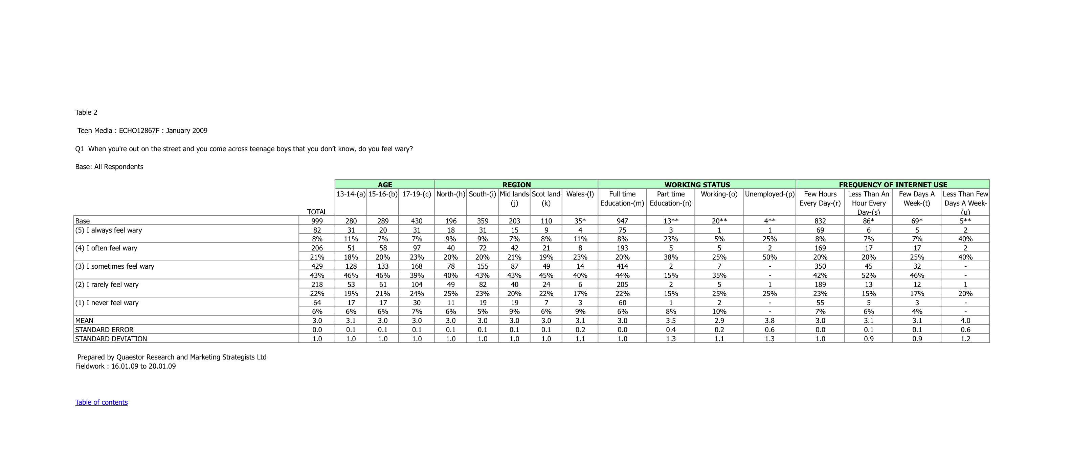

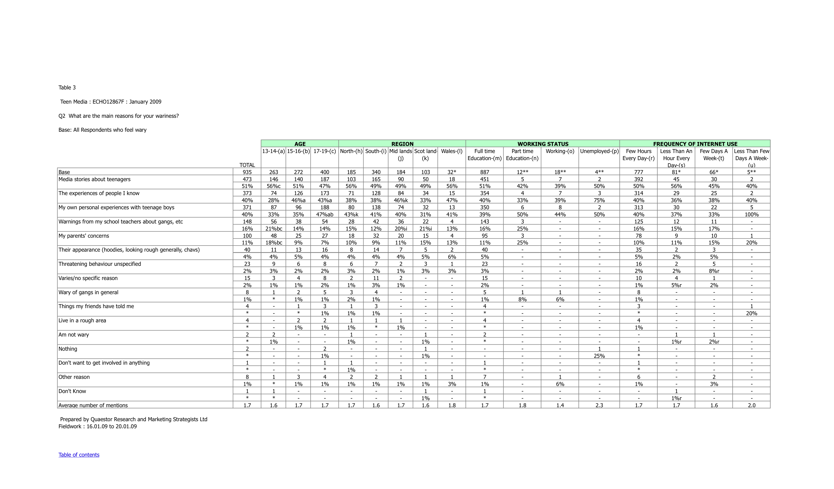
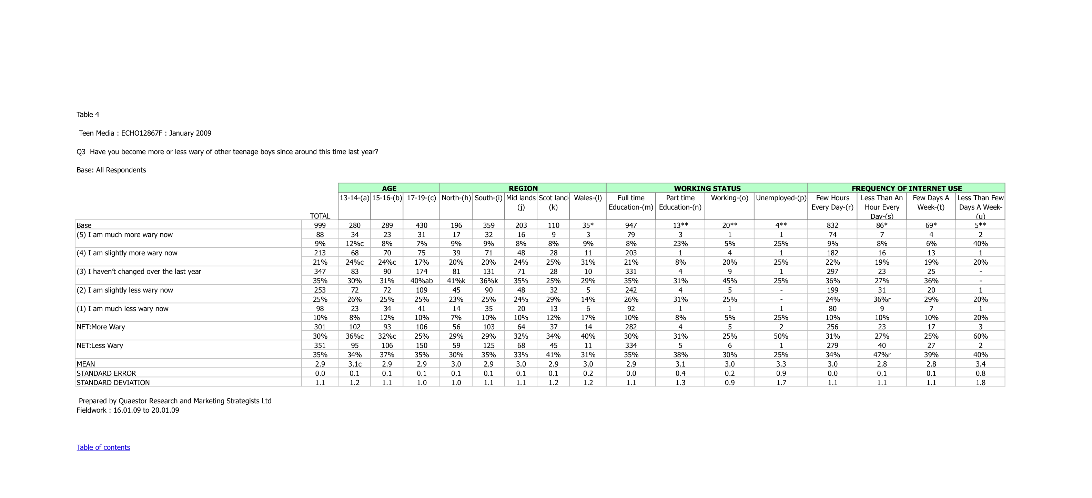
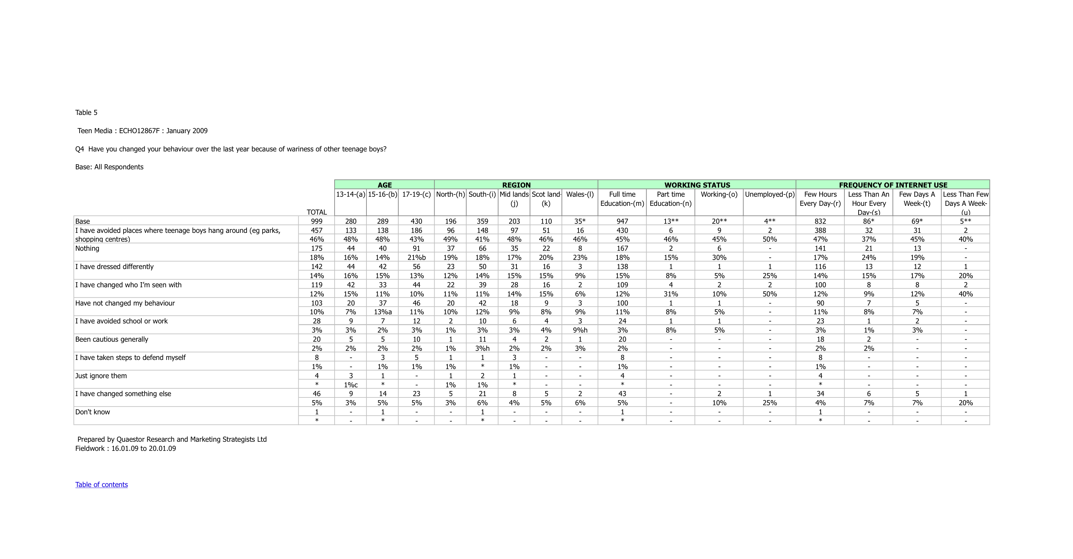

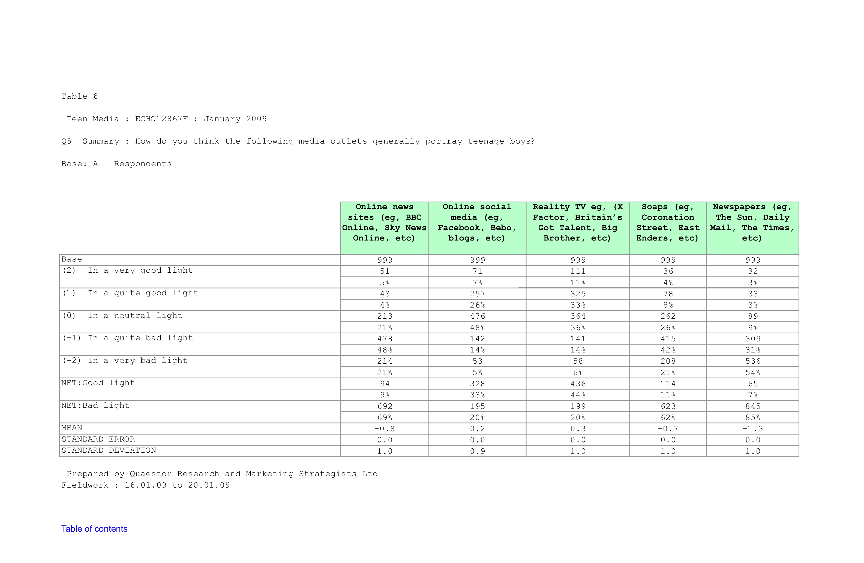
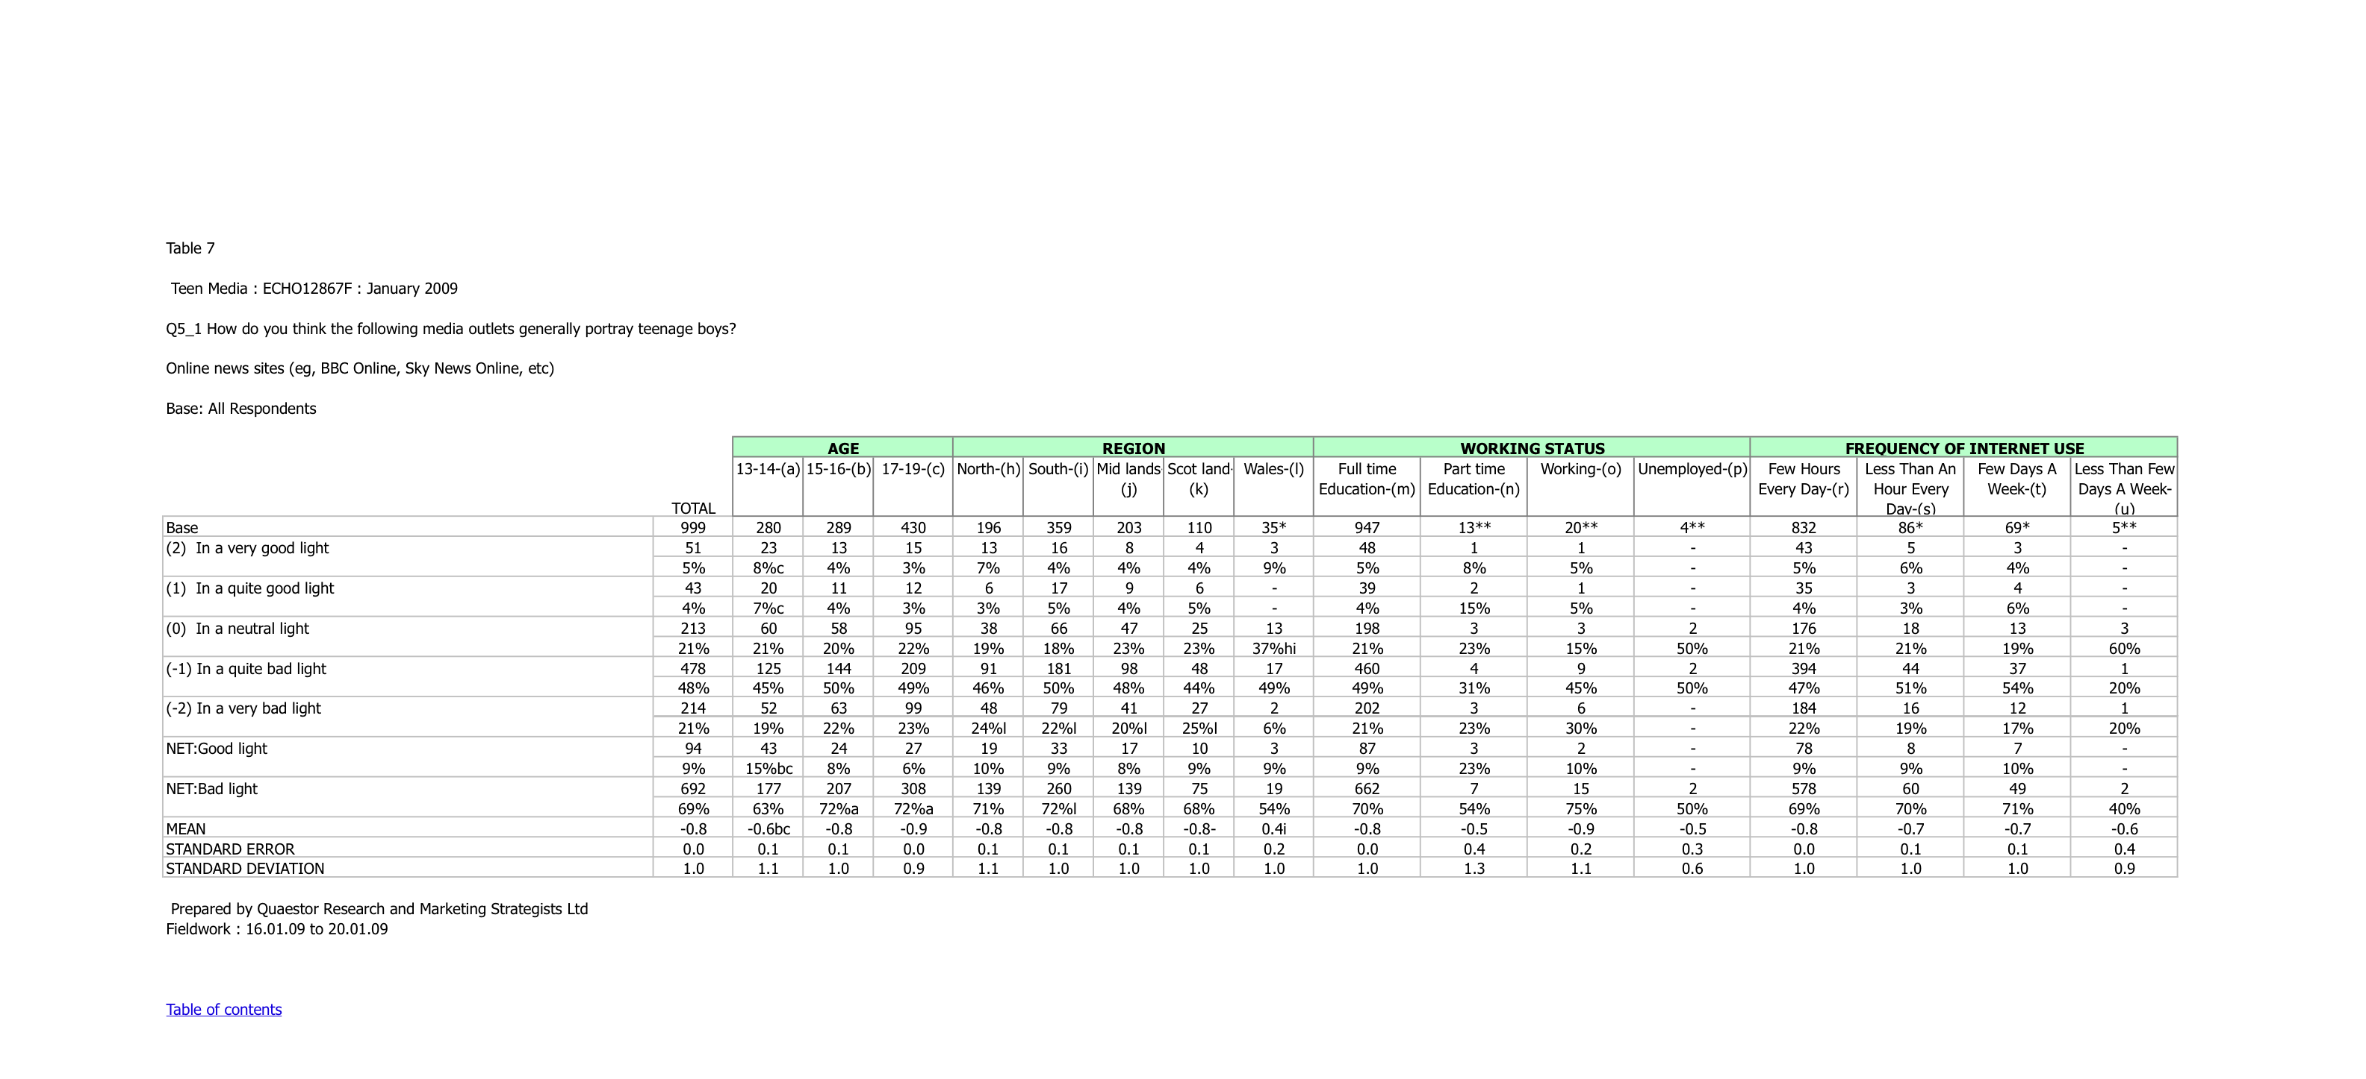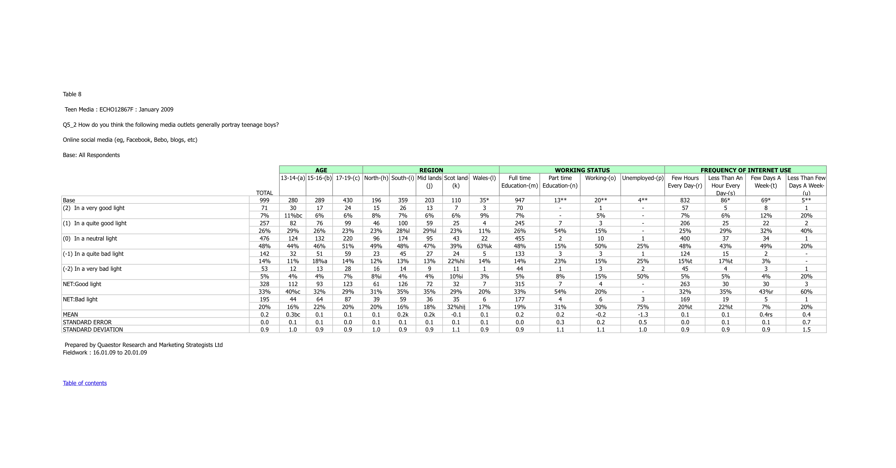
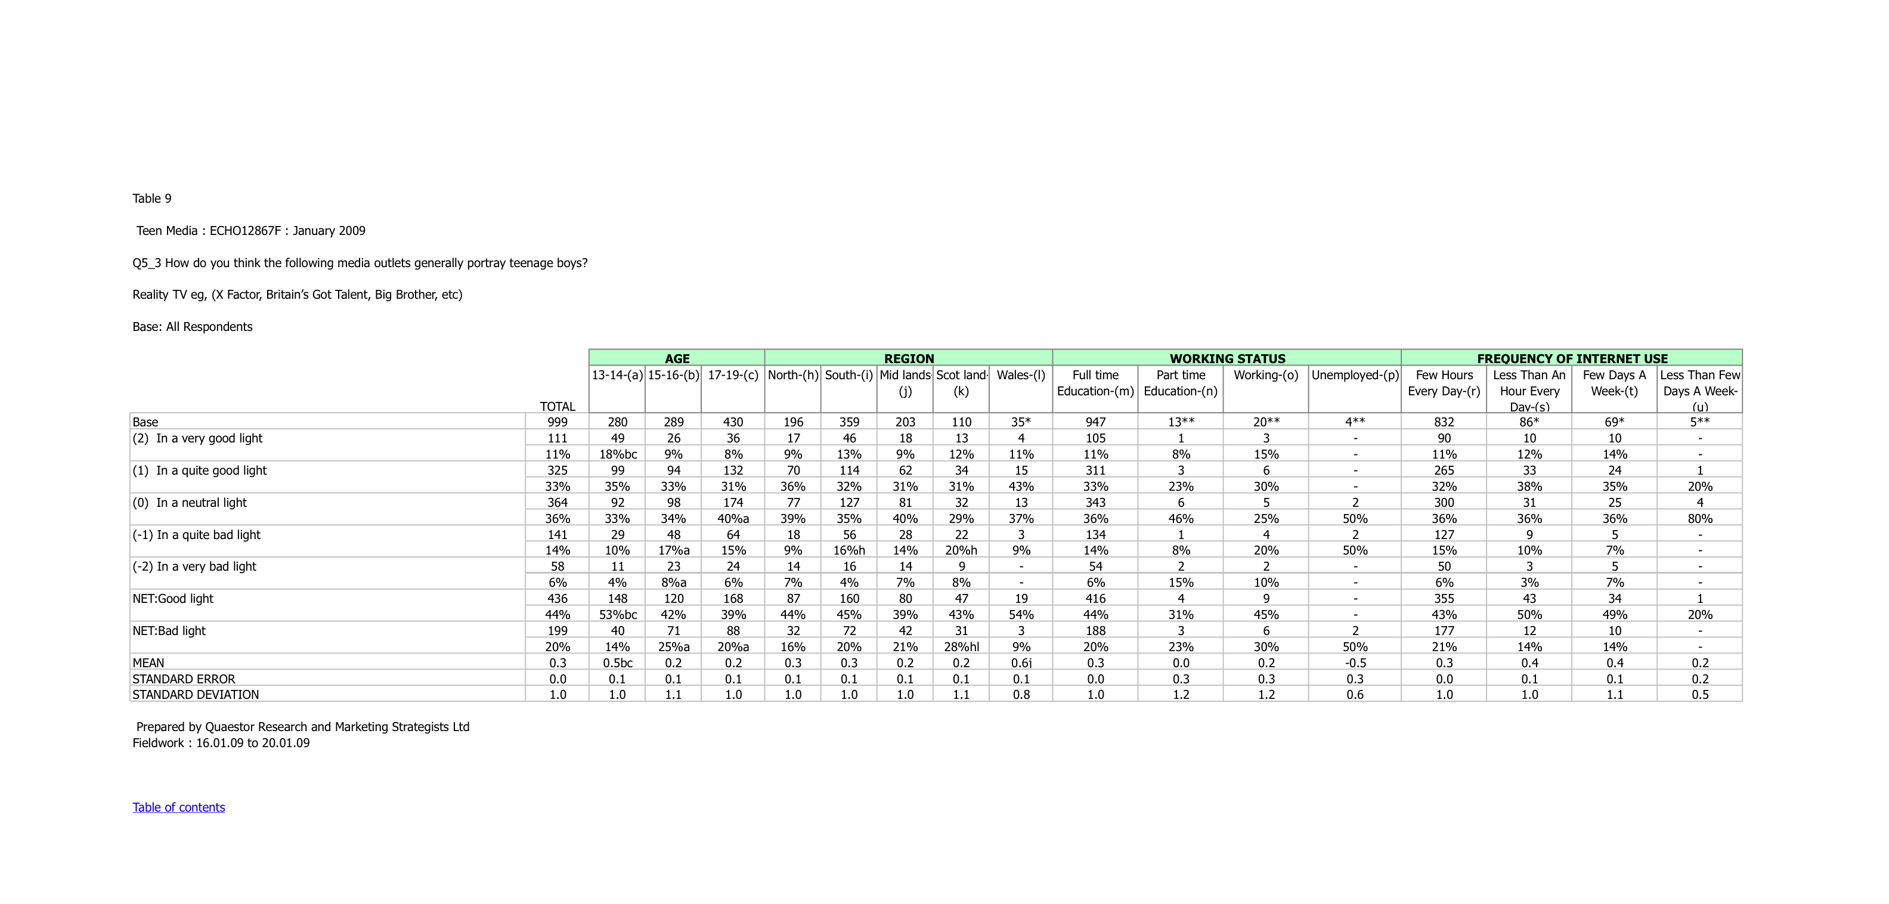

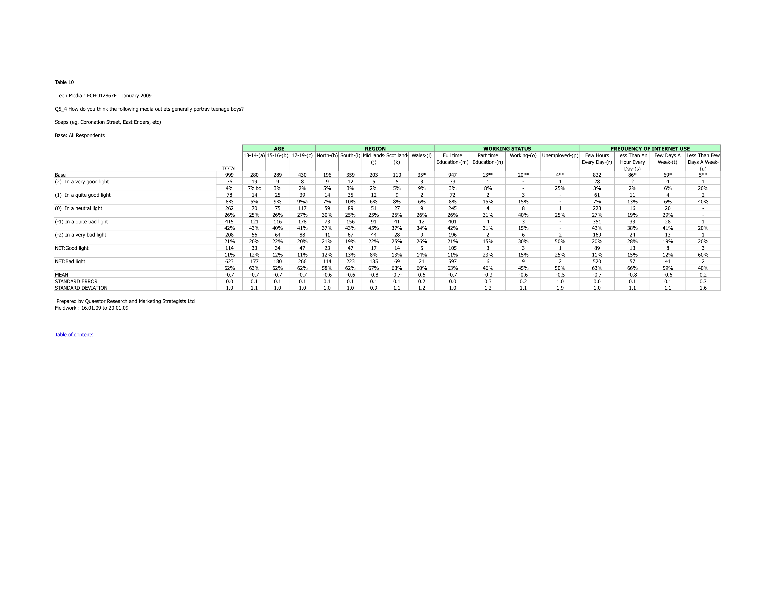
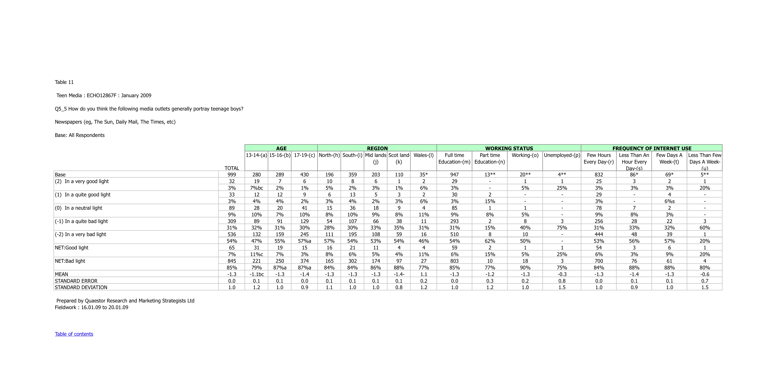
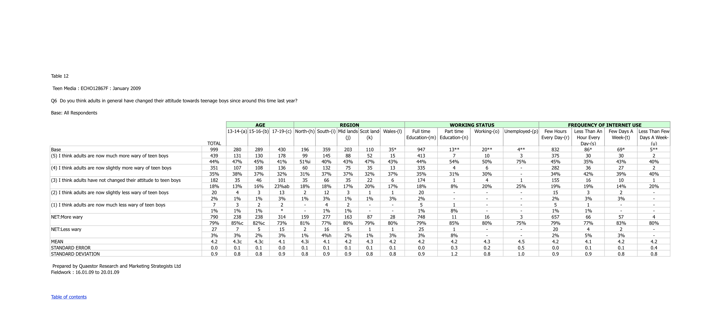

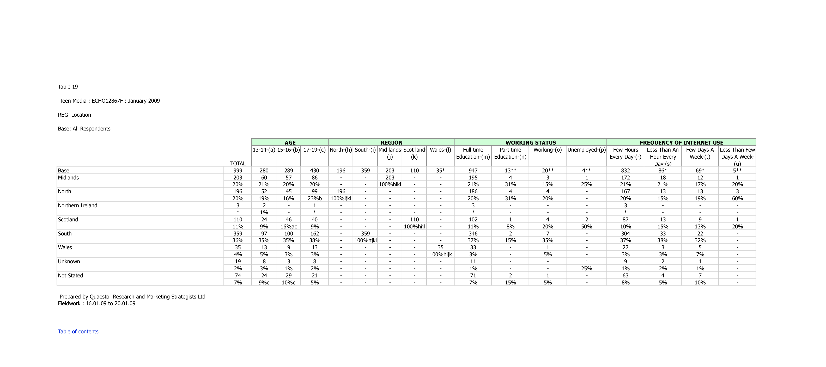

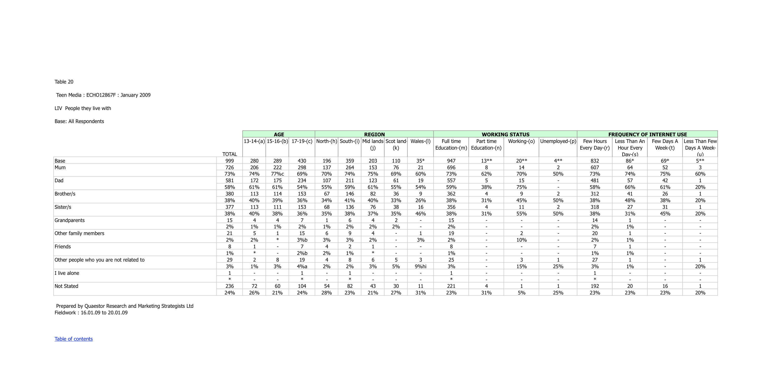
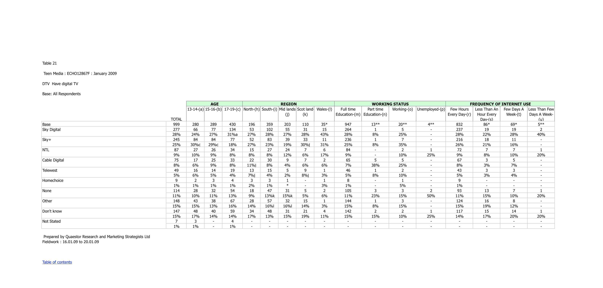

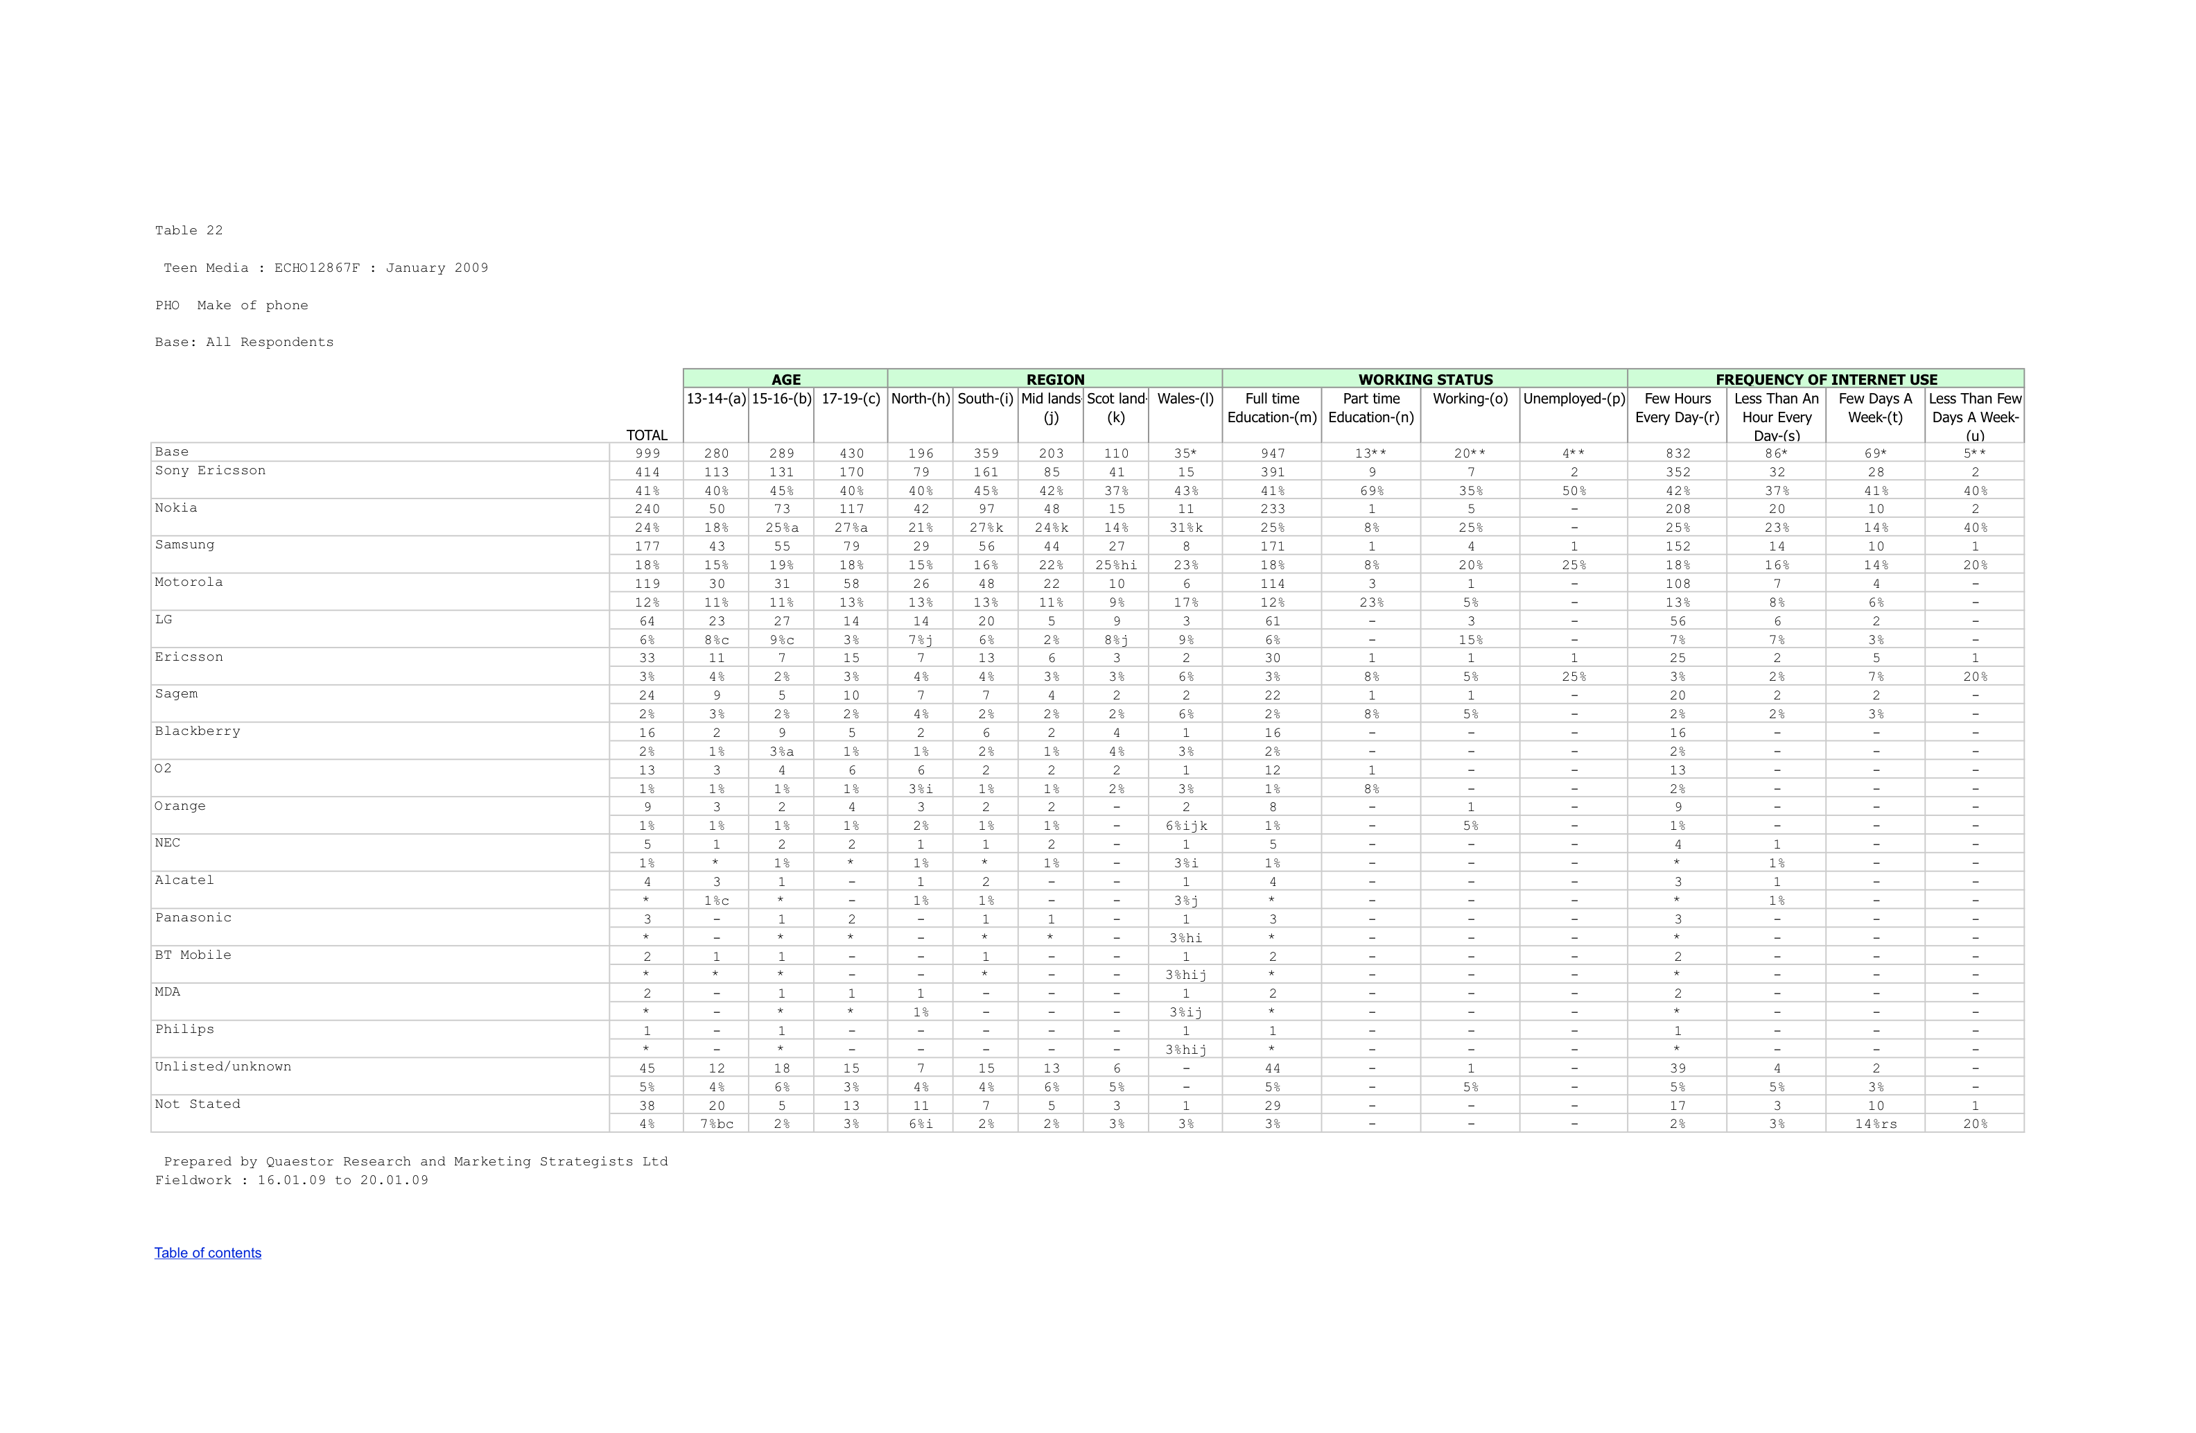
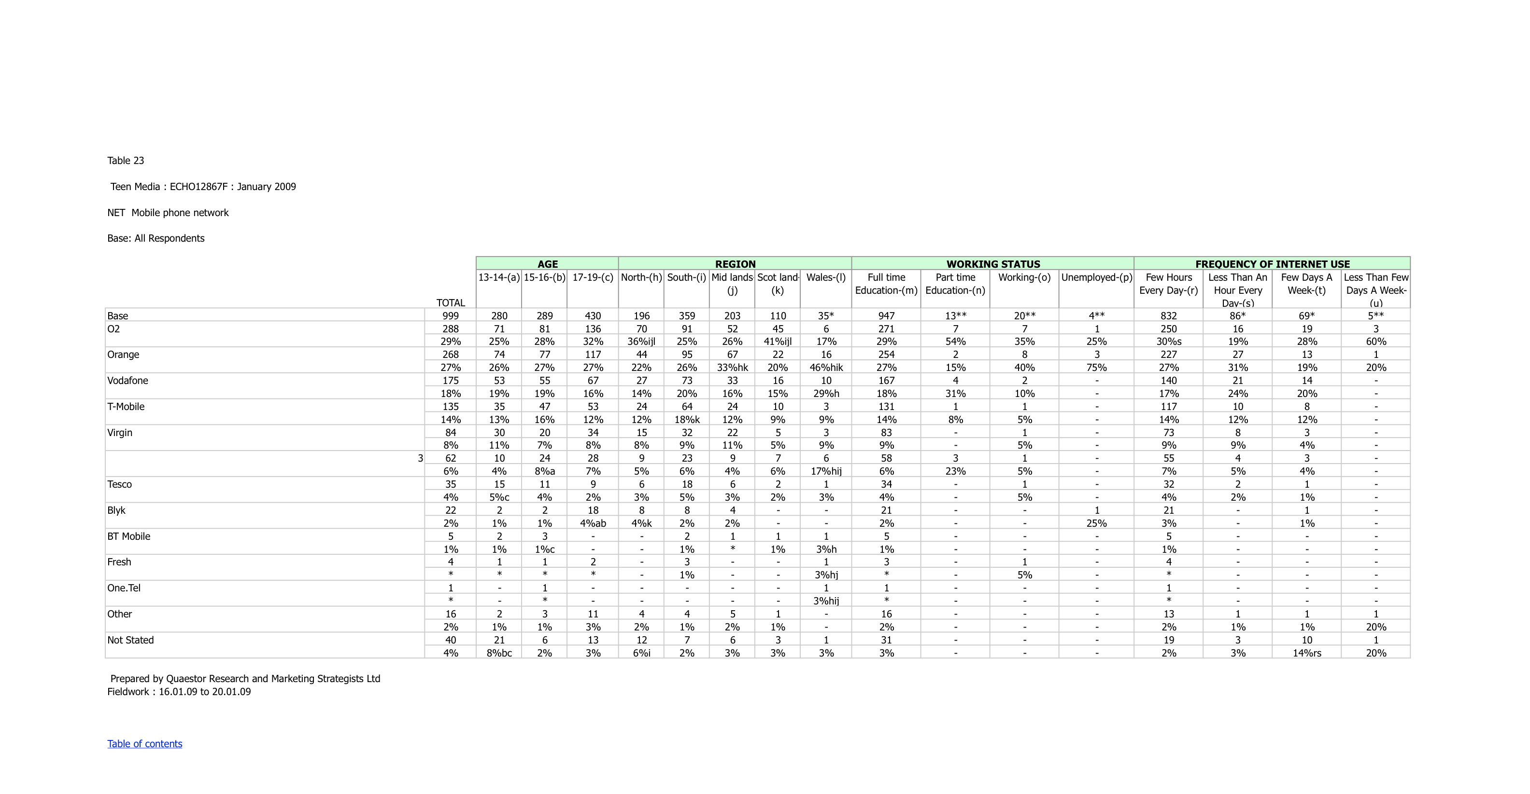
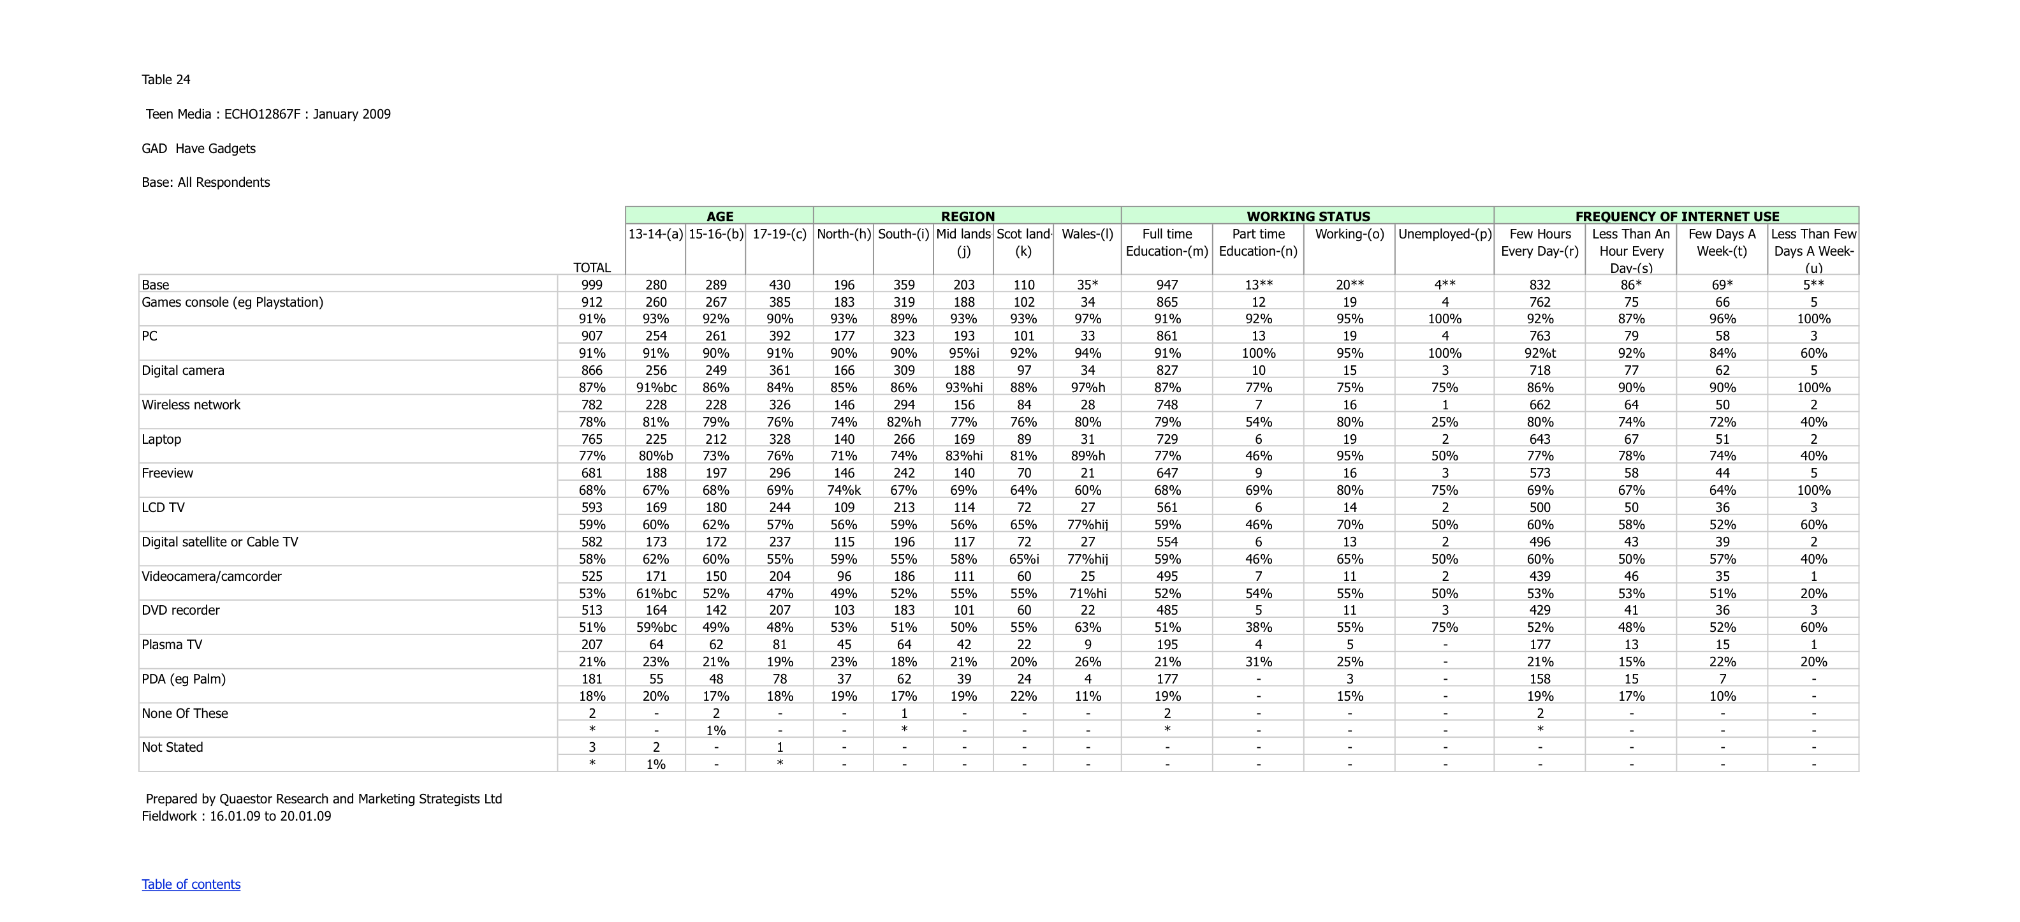

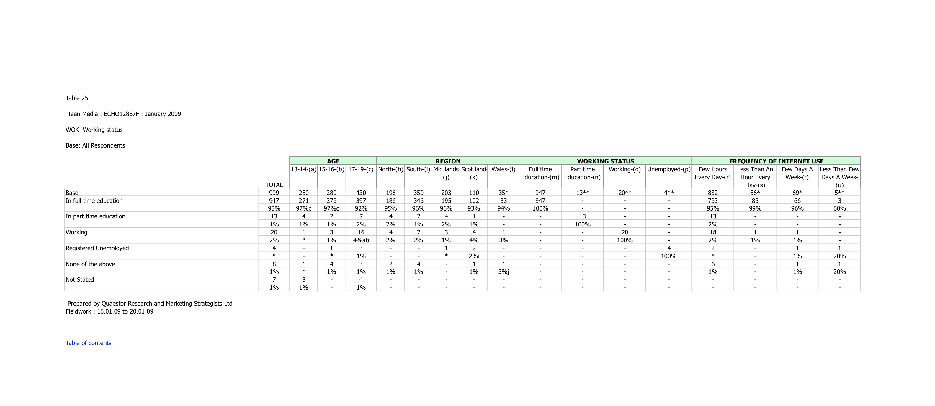

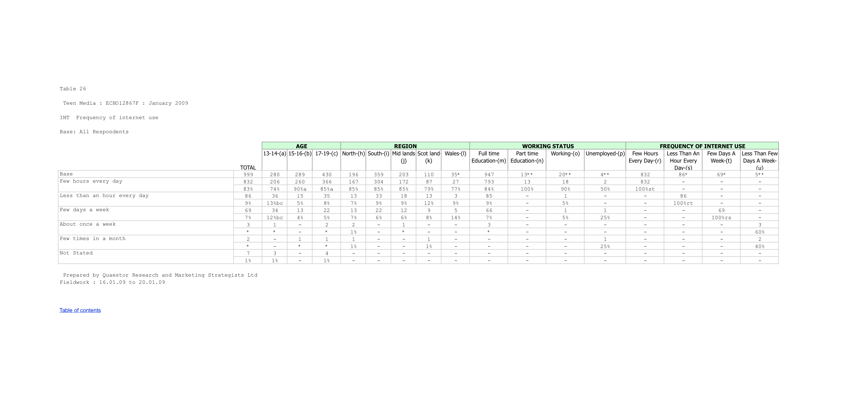
APPENDIX 3

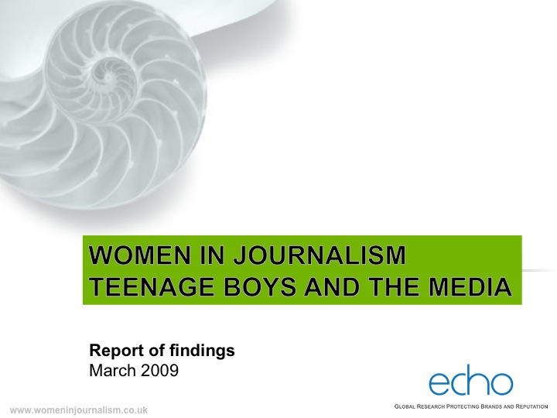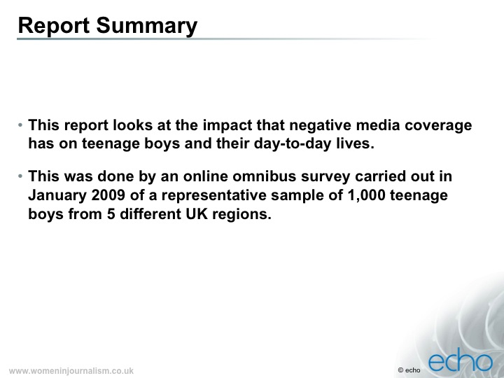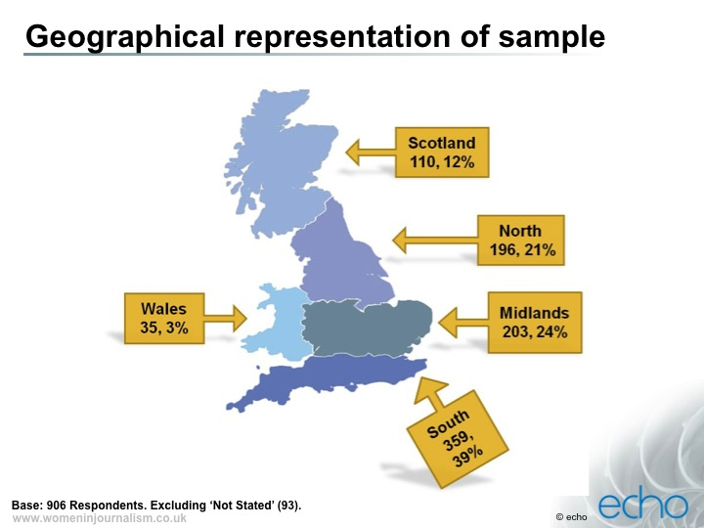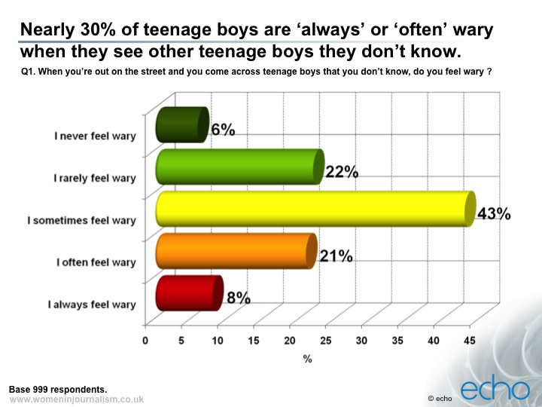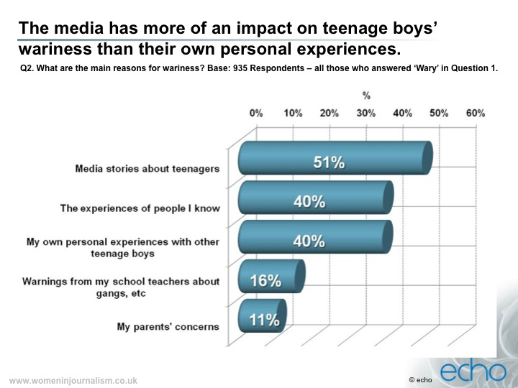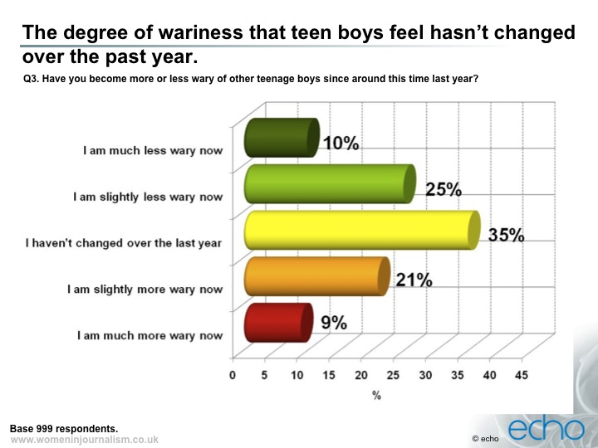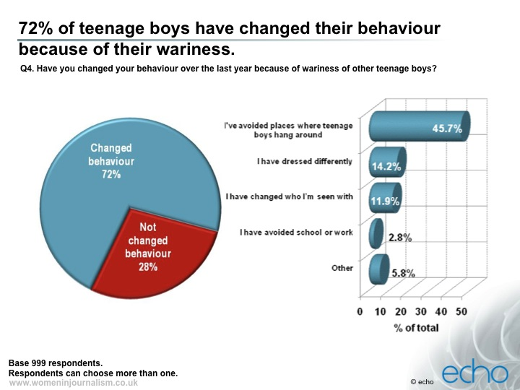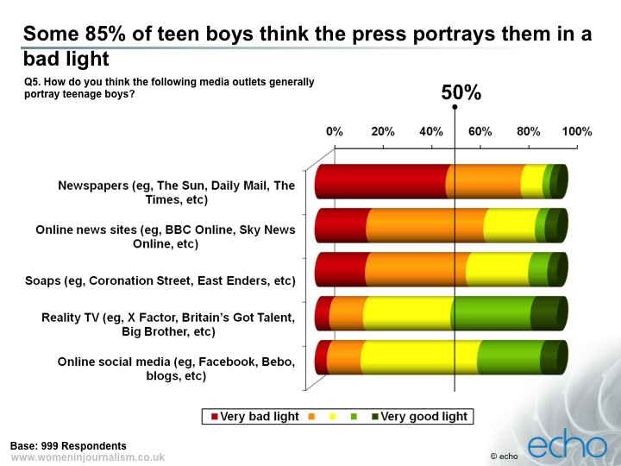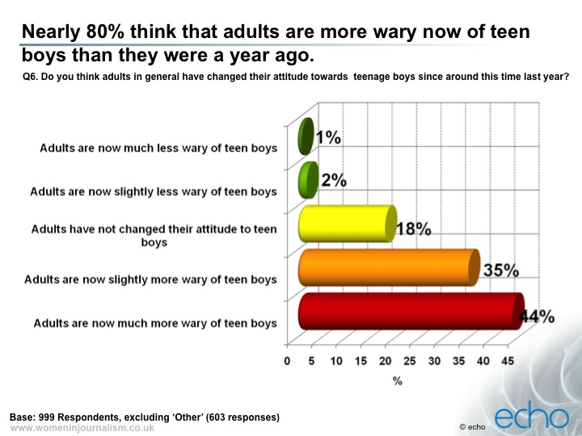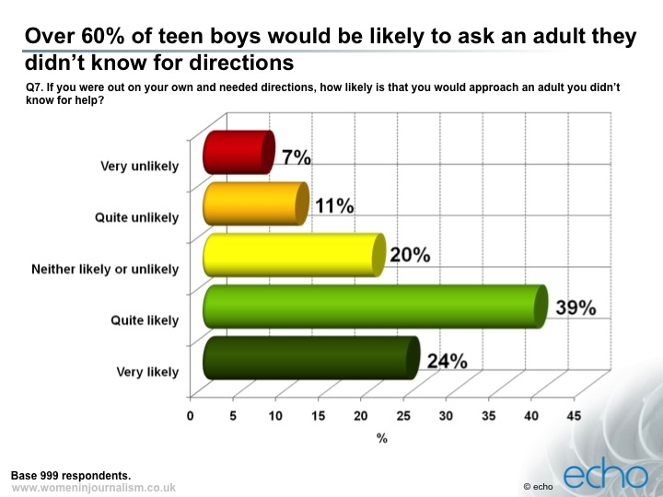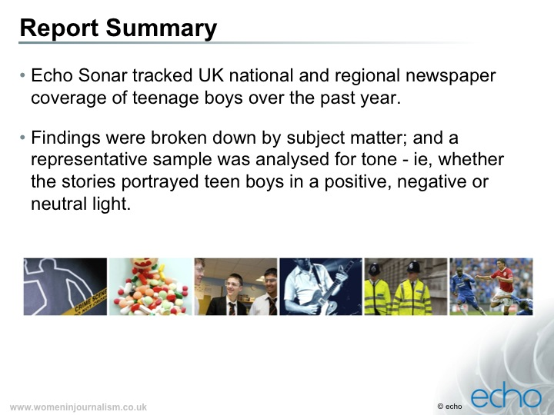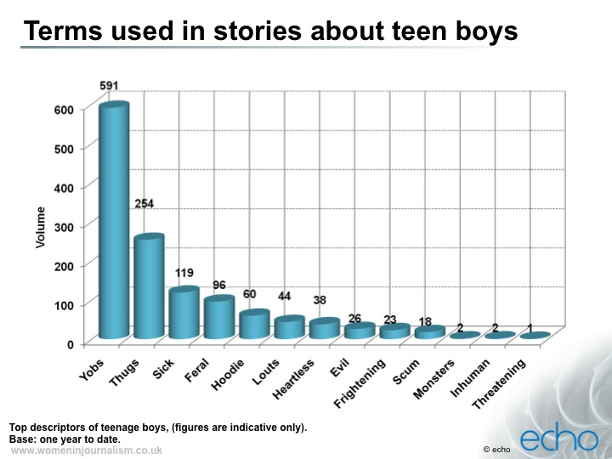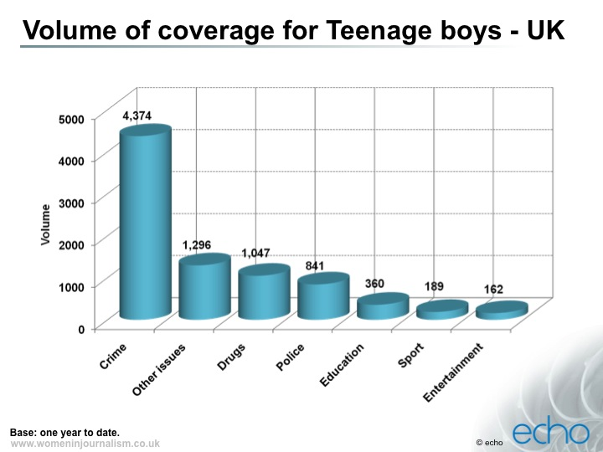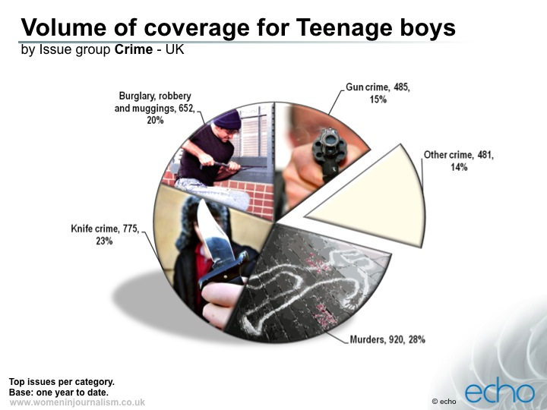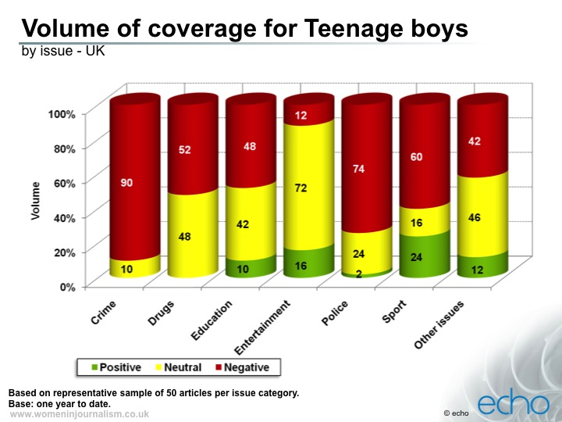

APPENDIX 4
Women in Journalism

‘Hoodies or Altar Boys?
What is media stereotyping doing to our
British boys?

Report by Fiona Bawdon, WiJ deputy chair
Research conducted by Echo

A Women in Journalism/British Library Summit
British Library Conference Centre
10 March 2009

www.womeninjournalism.co.uk
www.bl.uk
www.echoresearch.com

Contents

1. How the media sees teen boys, page 3

2. Background and introduction to summit, page 7

3. Good news is no news, page 9

4. Research findings, page 14-30

5. What is Women in Journalism?, page 31

1. How the media sees teen boys...

Yobs turn street into no-go zone at night
‘Gangs of teenagers are turning what is a popular market street by day into a no-go area at night.’ Islington Gazette, 25 February 2009

‘White working class boys are turning their backs on university even if they do well enough at school, a study revealed yesterday.’ Daily Mail, 19 June 2008

Tories promise 21st century clip round the ear for youth crime
Guardian, 24 February 2009

Juvenile delinquency
‘It is a strange anomaly, that in a country boasting to be the most civilized in the world, no effective machinery exists for checking the growth of vice in young offenders. Our gaols, as reformatories, are worse than useless.’ Morning Chronicle, 22 October 1842

‘We are a group of 14-year-old boys from the Reclaim project; since the project started, we have been approached by so many different newspapers, magazines and TV companies, most of who want to talk to us about guns and knives and gangs. We keep trying to explain that we are not involved in gangs and crime; we’re doing positive things in this area – and then journalists go away, as they tell us that’s not the story people are interested in…’ Open letter from Manchester-based Reclaim, published in Guardian, 25 August 2008.

Enforced conscription is the answer to sick yobs
Sue Carroll, Mirror, 2 March 2009

‘What word other than “feral” better describes the swarms of hooligans abandoned to their own devices by slattern mothers and absentee “babyfathers”? No one crosses the road if they spot a crocodile of Boy Scouts coming in the other direction. But nor does anyone in their right mind risk walking through a scrum of hoodies hogging the pavement – not unless they fancy a knife in their ribs.’ Richard Littlejohn, Daily Mail,18 November 2008

Sick vid posted by Rhys gangs
‘A street gang with links to the murder of schoolboy Rhys Jones have posted a sickening video glorifying violence. Footage shows an unidentified youngster who has apparently been kidnapped by violent thugs (see multimedia links, right)....’ Sun, 7 January 2009

‘If Obama gets in, I’m moving to America’
Young black British men on the role models that give them hope
Moboshir Ali, 19, currently looking for work: ‘Lewis Hamilton? Brilliant. Brilliant. Brilliant. Now he’s in the history books. It was so good. I don’t care about Obama, though. I give up on politics.’
Joshua Ellison, 17, student: ‘Hackney is my hometown, it’s easy to blend in – but if Obama gets in, I’m moving to America, bwoy! I’m excited about Lewis Hamilton, too, and really happy for him.’
Julius Soares, 19, engineering student: ‘A black man being president! It makes me feel in the future I can be whatever I want to be. He’s inspired me, definitely.’
Guardian, 4 November 2008 (the day after Lewis Hamilton won Grand Prix and the day before US elections)

‘Boy dad Alfie Patten yesterday admitted he does not know how much nappies cost – but said: “I think it’s a lot.” Baby-faced Alfie, who is 13 but looks more like eight, became a father four days ago…’ Sun, 13 February 2009

‘Heartless hoodies have snatched a cherished pet chicken from a Barnstable home... A gang of youths broke into the shed, stole several eggs, and tried to make off with a large white rooster, before setting for the small friendly bantam. The youths were then spotted the following day, chasing the chicken around Pilton. PC [Andy] Greenslade said: ‘…We won’t tolerate an innocent and friendly animal being tormented by a group of terrifying hoodies.’ 25 February 2009, This is North Devon

‘Police are appealing for witnesses after a lone have-a-go-hero was hospitalized by hooded Croydon thugs. The man, in his 50s, saw two men throwing snowballs at a stationary 197 bus parked in Morland Road about 6pm on February 4. He told them to stop and the two men turned their attention on him, becoming abusive.’ Croydon Guardian, 26 February 2009

Hoodies may be told to ‘show your face or leave’
‘Hoodies could soon be challenged in every Bodmin store in a bid to catch more criminals who have been covering their faces.’ This is Cornwall, 25 February 2009

Hoodies help out OAPs
‘College students are challenging the stereotype of hoodie-wearing teenagers being anti-social troublemakers by wearing theirs to carry out charity work, conservation and even shopping for the elderly.’ Lakeland Echo, 26 February 2009

Teenager given life sentence for stabbing over Xbox
Boy boasted ‘I’m the man’ as victim lay dying
Times, 21 February 2009

‘A battling Women’s Institute member was handed a criminal record yesterday for clipping a teenage vandal round the head with a roll of papers.’ Sun, 25 February 2009

Hoodies can sometimes be goodies too
‘…when I called to collect a vindaloo from the take-away…, I was wary when I discovered it was filled with a group of youngsters. The shop area was small and two lounged in chairs and two others crowded the doorway, wearing hoods and blank expressions…I wondered whether to give them a hard stare of avoid eye contact altogether. It was three steps up to the shop doorway and as I reached it, one of those sitting moved his legs, opened the door for me and told his mate to move. They politely got out of my way so I could collect my waiting meal and opened the door for me again as I left...’ ‘Denis’, Huddersfield Daily Examiner, 23 February 2009

‘A war veteran has been left housebound after vandals stole his £1,200 mobility scooter – and TORCHED it…Great-grandad Reginald [Hopton, 89], who served in Belgium, Holland, Egypt, Sri Lanka and India during the Second World War, wants the yobs to have a spell in the Army.’ Sun, 3 March 2009

2.Background and introduction

How Women in Journalism’s ‘Hoodies or Altar Boys?’ summit came about

In 2007, Women in Journalism staged its first ever summit looking at the impact of the media on the ambitions and aspirations of the next generation of young women.

‘Am I bovvered? What are teenage girls really thinking?’ was a great success, tapping into genuine and deep concern about what, if anything, may be going wrong with today’s young women. The event, chaired with great aplomb by Cherie Blair (and also staged with the help of the British Library), generated a great deal of media coverage and the debate about the issues raised continues to this day.

WiJ had intended the 2007 summit to be a one-off but, after having time to draw breath, we knew it was an experience we wanted to repeat. Having focused on teenage girls, the obvious topic for WiJ’s next summit was one close to many of our hearts: teen boys and the media. A number of us on the committee are mothers of sons and so have a strong personal as well as professional interest in the way boys are portrayed. There was a clear feeling that the reality of our boys’ lives and those of boys we know is entirely absent from much of the press.

When a photo of a group of perfectly ordinary lads, just standing around wearing hooded tops, has become visual shorthand for urban menace, or even the breakdown of society, it's clear that teenage boys have a serious image problem.

We wanted to look at why the teen boys’ ‘brand’ has become so toxic and, crucially, what impact this may be having on them, their view of themselves and their place in the world.

For all WiJ’s enthusiasm, this important event would not have taken place without the collaboration of the British Library, which was keen to be involved as part of its learning programme. The Library has provided the venue for today and other invaluable resources, including using its existing contacts with schools to make sure that young people are well represented in the debate today.

We also need to thank Echo for conducting the research pro bono and supporting us throughout the preparation and planning of this event. We are grateful for the vision of Echo’s group chief executive, Sandra MacLeod, who immediately saw the importance of what WiJ was hoping to do; and for the enthusiasm (and patience) of her team, in particular, David Holmes, Zareena Asad, Matt Painter and Lexie Cameron.

Also huge thanks to the WiJ organising team, Sue Matthias (WiJ chair), Rowenna Davis, Maureen Paton and Angela Neustatter. As ever, the biggest debt of thanks goes to WiJ’s administrator, Kate McMillan, who has done more than anyone to make this event happen.

3. Good news is no news

Do teenage boys get a raw deal from the media?
Teen boys themselves certainly seem to think so. According to the survey of 13-19 year olds commissioned by Women in Journalism, some 85% think newspapers give them a bad press. Just 6% of boys surveyed thought newspapers portrayed them fairly.
The independent research company Echo* surveyed 1,000 teenage boys across five UK regions. The findings showed that new media fared a little better than newspapers, with 31% of respondents saying the likes of BBC online or Sky News online portrayed teen boys in a good or neutral light. However, reality TV shows were seen as representing them most fairly, with 44% of boys surveyed saying programmes like X-Factor and Britain’s Got Talent portrayed them in a good light.
Before pictures of baby-faced
13-year-old Alfie Patten emerged,
teenage fathers barely featured
on the media’s radar

The research also tracked newspaper stories about teen boys across the national and regional press over the last year. They found coverage was unrelentingly negative and focused disproportionately on crime. Teenagers were referred to variously (in descending order of frequency) as yobs, thugs, sick, feral, hoodie, louts, heartless, evil, frightening, scum, monsters, inhuman and threatening. There were very few positive stories involving teens to balance the bad ones.
After news that 13-year-old Alfie Patten had apparently fathered a child, newspapers in recent weeks have been filled with tales of teenage dads. However, before pictures of baby-faced Alfie emerged, teenage fathers barely featured on the media’s radar. In the previous 12 months, stories about crime have dwarfed all other coverage of teenagers.
In the newspapers surveyed, researchers identified 8,269 stories involving teenage boys. More than half of these, 4,374, were about crime (split fairly evenly between burglary/robbery, knife crime, gun crime and murders). All other categories, such as education, sport, health or entertainment, accounted for just 3,895 stories.
Only 24% of stories about teens
and sport were positive;
only 16% of stories about them
and entertainment were positive

One of Women in Journalism’s most striking findings was how much teen boys are influenced by the bad press they get. It seems that the endless diet of media reports about yobs and feral youths is making them fearful of other teens. Nearly a third said they are ‘always’ or ‘often’ wary of teenage boys they don’t know; nearly three-quarters have changed their behaviour to avoid other teens. The most popular reason for their wariness, cited by 51%, was ‘media stories about teen boys’, compared with 40% who said their wariness was based on their own or friends’ bad experiences of other teens.
For all the coverage about teenagers, boys voices are rarely heard directly in the press. A 2005 study found that fewer than one in 10 articles about young people actually quoted young people, or included their perspectives in the debate.
For much of the press, there is no such thing as a good news story about teenagers. Stories about sport and entertainment, which might have balanced other negative coverage, also often took a critical line. Echo analysed a representative sample of stories on a range of topics to see whether teen boys were portrayed positively, negatively or neutrally: only 16% of stories about teens and entertainment were positive; only 24% about teens and sport were positive. For example, one story about teenagers and the Olympics worried that yobs and hoodies will tarnish Britain’s image during the 2012 Games.
A photo of perfectly ordinary lads standing around wearing hooded tops is used by the press as visual shorthand for menace, or even the breakdown of society. Clearly, the teen boys’ ‘brand’ has become toxic: if teen boys were a chemical company they’d be Union Carbide; worse, if they were a banker, they’d be Fred Goodwin.
The teen boys’ ‘brand’ is toxic:
if teen boys were a banker,
they’d be Fred Goodwin

However, Jonathan Bottomley, head of planning at ad agency Bartle Bogle Hegarty thinks it’s the newspapers not the teens that need a makeover. His company has a strong incentive to know what teens are really like, so BBH can market to them effectively. If teens really were all knife-wielding hoodies, companies like his would rapidly go out of business, he concedes.
Far from being identikit yobs, teenage boys have never had such a broad and disparate range of interests and characteristics – not least because of an increasingly fragmented media which can serve these different teen audiences.
While real teens are being demonised in the adult press, adults in their 30s and 40s have fetishised the good bits of being a teen, says Bottomley. ‘People in ad agencies like this ours, will come into work in trainers, with angular haircuts and wearing Bathing Ape clothes.’ Teenage behaviour is only acceptable if you’re over 30, it seems.

We did, however, find some news coverage where teen boys were described in glowing terms - ‘model student’, ‘angel’, ‘altar boy’, or ‘every mother’s perfect son’. But sadly, these descriptions were reserved for teenage boys who had met a violent and untimely death during the course of 2008.
Fiona Bawdon, March 2009

* Echo Research is an independent reputation and communication research specialist with a twenty-year track record in undertaking stakeholder studies and media content analysis. Echo provides support to clients in the private and public sectors, universities, regulators and NGOs as well as to more than one quarter of FTSE and Fortune 100 quoted companies. www.echoresearch.com
5.What is Women in Journalism?
Women in Journalism was founded in 1995 as a networking, campaigning, training and social organisation for women journalists who work across all the written and new media. We have over 530 members, including many of the most senior women in the industry. Unlike other media organisations, we welcome both magazine and newspaper journalists, attracting both staff and freelancers, prominent editors and more junior writers. We currently have a 55/ 45 split between freelance and staff members.

WIJ seminars
The sharing of experience and knowledge is one of the fundamental aims of the organisation. WIJ seminars are unique in being able to draw on the expertise of so many leading journalists and editors from a wide range of newspapers and magazines, all of whom recognise the value of encouraging talented women. We cover subjects close to every journalist's heart. Leading journalists, authors and social commentators usually make up the panel.
We run a programme of six seminars each year which are attended by 70 to 100 writers. Typical or regular seminars include:

* Writing that book (with major UK publishers and agents);
* The art of the interview, where some of the most famous interviewers in the national press have shared the tricks of their trade.
* From sub-editor to editor
* The great features debate
* ‘What do you want to be when you grow up? Career development for journalists.
* From magazine to web
* Perfect pitch – what commissioning editors really want
*"Use it or lose it’’, based around WIJ research into ageism

In September 2007, WiJ staged its first summit: ‘Am I Bovvered?; What are teenage girls really thinking?’ What is media stereotyping doing to the ambitions and aspirations of the next generation of young women?
Research
We regularly conduct research on subjects close to our members’ hearts, and our findings generally attract widespread media coverage. Recent research papers have included: Chaps of both sexes; The hidden sex; Women in the news; The cheaper sex.

WIJ and government
We have also run joint seminars with the Cabinet Office, to encourage women to apply for public appointments, and we regularly hold networking events at the party conferences.
WIJ website
Our website remains the essential link to the Women in Journalism community: it's the medium through which we communicate with our members (through newsletters, bulletin boards, jobs vacancies, events listings); and it is also our shop window to the wider world.
www.womeninjournalism.co.uk

Women in Journalism’s founders’ lunch

Women in Journalism’s founders’ lunch is an occasional “big name” event specifically designed for those women who supported the organisation when it began 11 years ago, plus specially invited guests from the media.

Previous speakers have included US Vogue’s ultra-chic editor-in-chief Anna Wintour, the Daily Mail’s best-known columnist, the late Lynda Lee Potter, and CNN’s redoubtable foreign correspondent Christiane Amanpour.

Maureen Dowd, the New York Times columnist who floors with almost every punch, spoke at the fourth WiJ founders’ lunch in spring 2006 with an audience of women from the highest levels in publishing.

Wij parties

We hold parties twice a year, in summer and at Christmas, for our members, plus specially invited guests, including leading figures from the publishing world. These events are an ideal opportunity for women journalists to network and share experiences.

www.womeninjournalism.co.uk
wijuk@aol.com

APPENDIX 5

PRESS RELEASE

EMBARGOED UNTIL 12PM Monday 9th March 2009
'Hoodies or Altar Boys? What is media stereotyping doing to our
British boys?’
Impact of media demonisation on teenage boys: launch of exclusive research by Women in Journalism.

Research specially commissioned by the campaigning group Women in Journalism will be launched at a summit being organised jointly with the British Library on Tuesday 10 March.
This ground-breaking event will include a panel discussion about the research findings chaired by the best-selling children's author Anthony Horowitz. On the panel will be: David Lammy MP, Minister of State for Higher Education; Mail on Sunday columnist Suzanne Moore; former Sunday Mirror and Sunday Express editor Eve Pollard; Mobo winning producer and DJ Dexplicit; Wilson Joaquim of the London Boxing Academy; Nathalie McDermott of the social organisation On Road Media.
As well as 100 journalists, policy-makers, campaigners and educationalists, the audience at this unique event will include over 100 teenagers from schools around the country.
Research findings include:
* 85% of teen boys said newspapers portray them in a bad light
* Reality TV was seen as portraying teen boys most fairly
* Media stories about yobs and hoodies are the main reason why teen
boys are wary of other teenagers
* 80% of teen boys think adults are more wary of them now than they were a year ago.
* Terms used in newspaper stories about teen boys included thugs, yobs, hoodies, feral, evil, lout, monsters, brutes, scum, menace, heartless, sick, menacing and inhuman
* Over the past year, there were more newspaper stories about teens and crime (as victims or offenders) than about teens and all other subjects put together
* Even on subjects other than crime, few newspaper stories show teen boys in a good light: only 24% of stories about teens and sport were positive about teenage boys; only 16% of stories about teens and entertainment were positive.
Fiona Bawdon, the WiJ committee member who will be presenting the research, says: “When a photo of a group of perfectly ordinary lads standing around wearing hooded tops has become visual shorthand for urban menace, or even the breakdown of society, it's clear that teenage boys have a serious image problem. The teen boys' "brand" has become toxic. Media coverage of boys is unrelentingly negative, focusing almost entirely on them as victims or perpetrators of crime - and our research shows that the media is helping make teenage boys fearful of each other.”
Roger Walshe, Head of Learning at the British Library says: "The event will be a genuine opportunity for young people to engage in discussion with media figures and policy makers. There is a lot written and said about teenage boys and this is a chance for them to have their say."

The research was conducted by Echo, which surveyed a representative sample of 1,000 teenage boys aged 13-19. Echo also tracked regional and national press coverage of teen boys over the past year. Research was carried out in January 2009.
www.womeninjournalism.co.uk

-Ends-

For more information about the research, contact Women in Journalism committee member Fiona Bawdon: fiona.bawdon@blueyonder.co.uk; 07740 644474; 020 8211 0903
If you would like to attend the summit on 10 March (being organised by Women in Journalism and the British Library), contact wijuk@aol.com

For information about the British Library, please contact Jacob Lant or Miki Lentin at the British Library Press Office, jacob.lant@bl.uk or 020 7412 7150

Notes to editors:
The British Library is the national library of the United Kingdom and one of the world's greatest research libraries. It provides world-class information services to the academic, business, research and scientific communities and offers unparalleled access to the world's largest and most comprehensive research collection. The Library's collection has developed over 250 years and exceeds 150 million separate items representing every age of written civilisation. It includes: books, journals, manuscripts, maps, stamps, music, patents, newspapers and sound recordings in all written and spoken languages. www.bl.uk
Women in Journalism is a networking, campaigning, training and social organisation for women journalists who work across all the written media, from newspapers and magazines to the new media. www.womeninjournalism.co.uk
Echo Research is an independent reputation and communication research specialist with a twenty-year track record in undertaking stakeholder studies and media content analysis. Echo provides support to clients in the private and public sectors, universities, regulators and NGOs as well as to more than one quarter of FTSE and Fortune 100 quoted companies.

APPENDIX 6

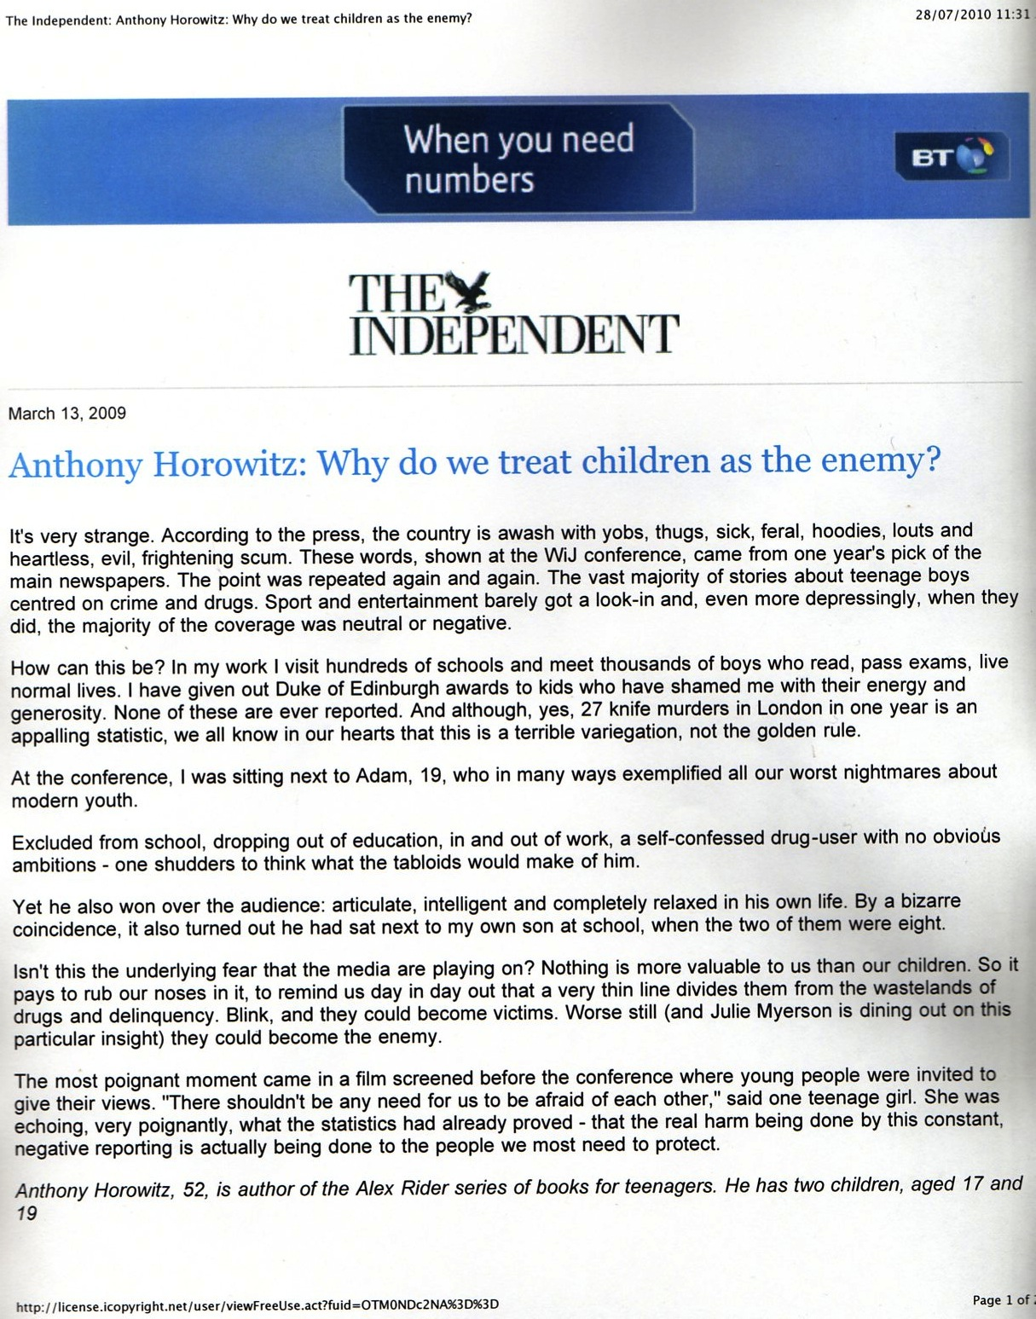

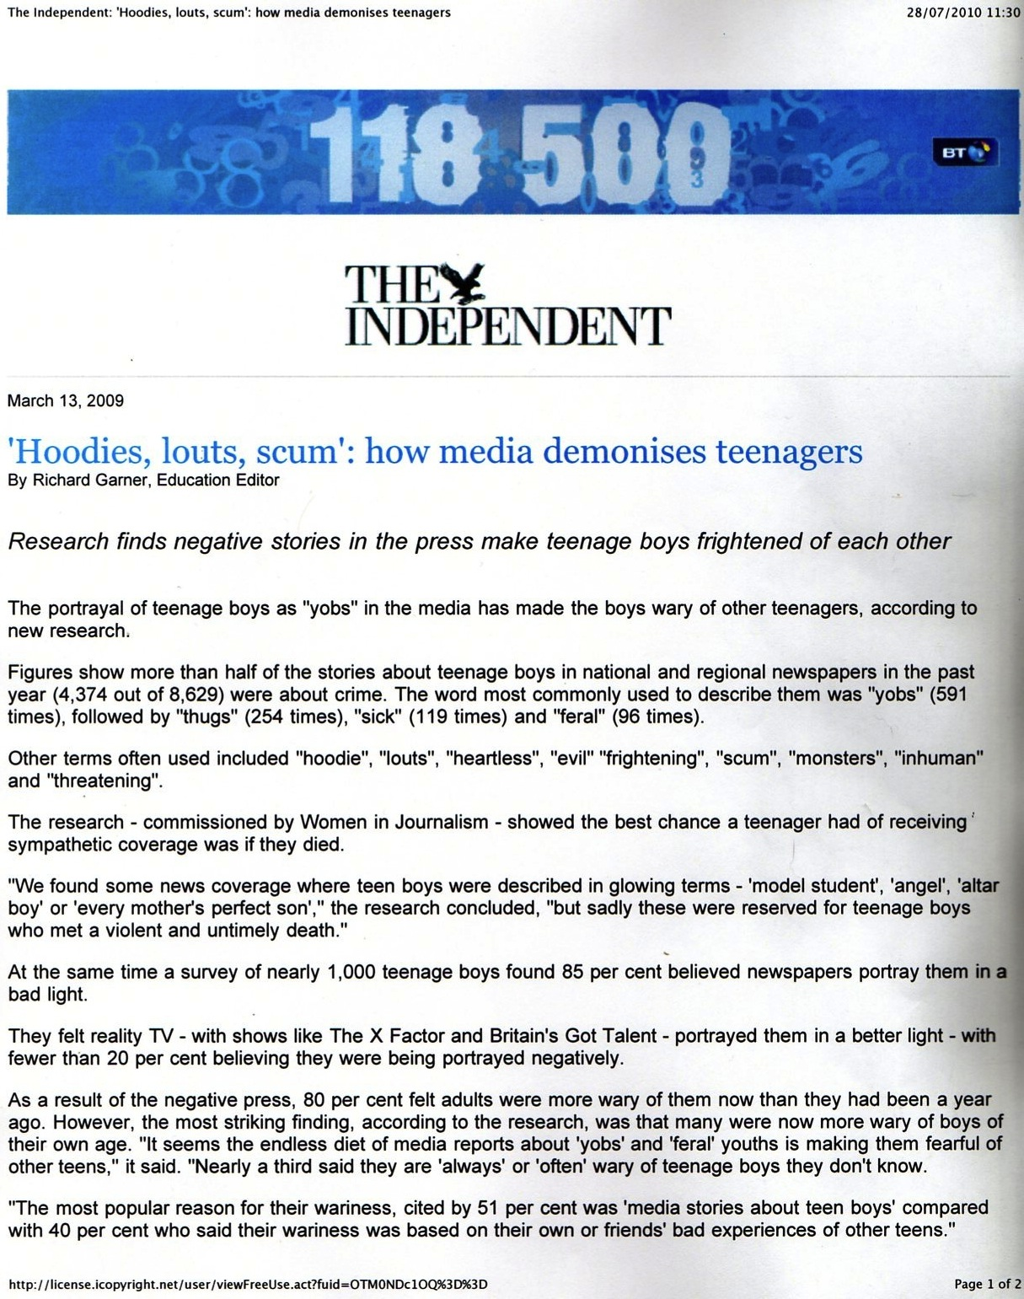

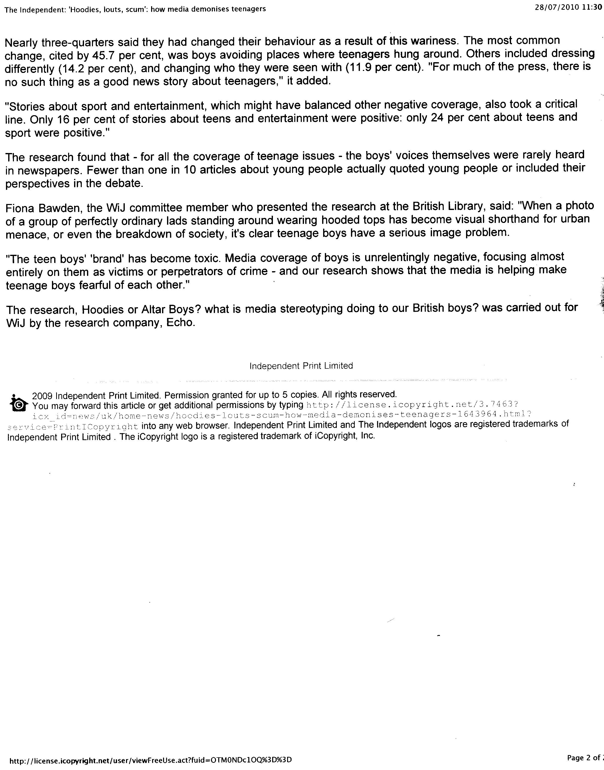

APPENDIX 7

